SYSTEMS 2000
INFINITY
UNIT INVENTORY
USER MANUAL

CONTENTS

START-UP 3

INFINITY COMPANY INVENTORY INFORMATION SET-UP 4
The Unit Inventory user manual guides you through the process of inputting the necessary information about all your unit types, allowing you to run the Infinity system efficiently in your dealership.
For each of the unit types, you will enter information concerning the specific unit, which will be used throughout the various Infinity modules.

ADD / MODIFY MISCELLANEOUS 5
The Miscellaneous tab has 14 buttons. Four buttons are associated with different drop down lists found in this module, three buttons are related to Datasheets, four buttons explain how to display units on the Internet, one button explains how to export your inventory to your Pocket PC, one button shows the latest programming changes made to the Infinity system, and one button for GM customers.

ADD / MODIFY ACCESSORY CODES 5
The Accessories tab display all installed options and accessories for the unit in a drop down list format. This list of accessory codes can be pre-loaded under the Miscellaneous tab.

ADD / MODIFY VEHICLE STATUS 5
The Status relates to the description of the unit. For example; Sold for a sold unit, Pending for a pending unit…The system allows you to enter any description of your choice and choose a color associated with the status for easier recognition. The Status color will appear on the background screen of the unit.

SET UP MAKE AND MODEL PICK LIST 5
The Infinity system allows you to set-up the drop down list for the “Model” list. This process will create a drop down in the system, by choosing a Model from the drop down the Make of the unit will update automatically.

SET UP UNIT DETAILS PICK LIST 5
The Infinity allows you to change the choices available within the drop down lists throughout the module. Example; the unit Type list, the Color list, the Fuel Type list, the Transmission Type list…

Standard Datasheet 6
This is a detail list of all your units in inventory.

Utility Trailer Datasheet 6

Marine Datasheet 6

Display all Units on Internet 6

Display all New Units on Internet 6

Display all Used Units on Internet 6

Unmark all Units from Displaying on Internet 6

Pocket PC Export 6

Changes Made

VIEWING OR ADDING FINANCIAL INFORMATION ABOUT A UNIT 8

FINANCIAL TAB 8

INPUTTING A UNIT 10

INPUTTING BASIC COMMON INFORMATION ABOUT A UNIT 10

INPUTTING DETAILED INFORMATION ABOUT A UNIT 12

AUTO 12

RV MOTORIZED 13

TRAVEL TRAILERS 14

MOTORCYCLES 15

MARINE 16

UTILITY TRAILERS 17

Manufactured Homes 18

Bus 19

CLASS 8 TRUCKS 20

Consignment 21

INTERNET 22

VIEWING OR ADDING ACCESSORIES TO A UNIT 23

ACCESSORIES TAB 23

VIEWING UNIT CUSTOMER HISTORY INFORMATION 24

CUSTOMER TAB 24

VIEWING IMAGE OF THE UNIT 25

VIEWING SERVICE REPAIR INFORMATION 26

UNIT INVENTORY SEARCH 27

REPORTS & WINDOW STICKER 28

SYSTEMS 2000
INFINITY
UNIT INVENTORY
USER MANUAL

START-UP

Welcome to the Systems 2000 Infinity Unit Inventory User Manual.

The Infinity Unit Inventory System is designed to accommodate all dealerships regardless of product line. Whether your dealership handles automotive, RV, travel trailer, motorcycle, marine or a combination of different product lines, Infinity will do the job effortlessly and efficiently.

WHAT YOU SHOULD HAVE BEFORE STARTING

- Company Information (e.g. Location, Dealership Number, Salesperson Number…)

- Units’ Information (e.g. Year, Make, Unit Type, Model, New, Used, Identification Number…)

INFINITY COMPANY INVENTORY INFORMATION SET-UP

INFINITY UNIT INVENTORY MAIN SCREEN

Infinity creates efficiency by supplying you with all the necessary data on one screen. Infinity is flexible, customizable, easy-to-use.

The Infinity Unit Inventory Main screen has 17 tabs: 9 associated with different inventory unit types and 8 that display information relative to the unit currently being viewed.

Keep in mind that you can disable any unwanted tabs (See the Infinity Security Manual) if you do not sell a particular type of unit.

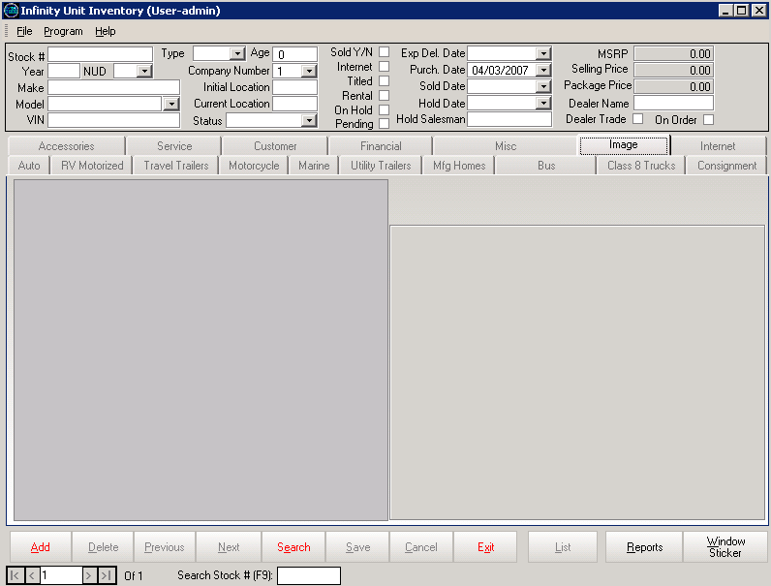
(IN. 1)
UNIT INVENTORY MAIN SCREEN

- Note: Remember to click the Save button after each update.

ADD / MODIFY MISCELLANEOUS

Under the Miscellaneous Tab
The Misc tab contains options for setting up various drop down lists and pick lists that will be used on diverse screens throughout the Infinity Unit Inventory Module. Examples: drop down lists for Accessory Codes and Vehicle (unit) Statuses and the pick lists for Make, Model and Unit Details such as color, body style, GVW (Gross Vehicle Weight), etc. Click the appropriate button to select a category to set up or modify.

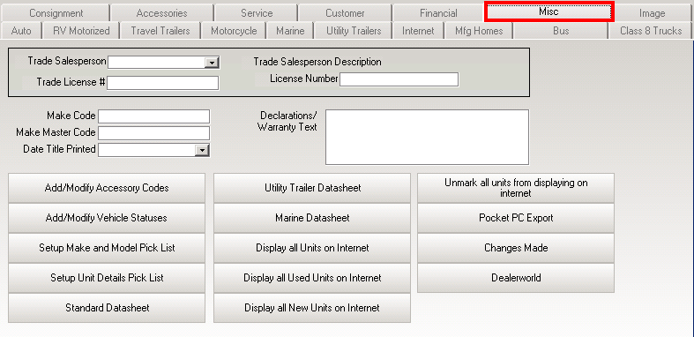

Set up

MISCELLANEOUS SCREEN

To set up the various drop down lists and pick lists follow the examples below.
Set up example: click on the Add / Modify Vehicle Statuses button located on the Miscellaneous screen; the Add / Modify Statuses screen will appear (see below).

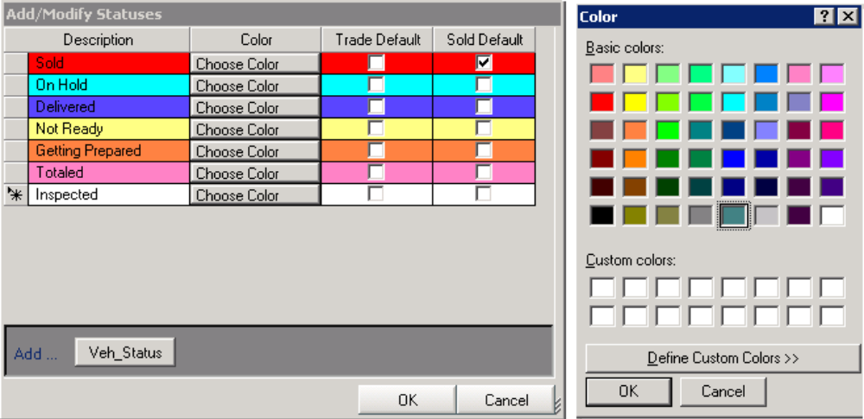

Click on the Add Veh Status button and then type a status description on the line that appears. For example, suggested vehicle statuses include Sold, On Hold, Not Ready, Getting Prepared, Totaled, and Inspected.

Then, click on the Choose Color button; the Color screen will appear; pick a color and then click OK. The color you select will become the background screen color for every unit in your inventory matching the description you entered.
Set up example: click on the Setup Units Details Picks List button located on the Miscellaneous screen; the Add / Modify Pick List screen will appear (see below).

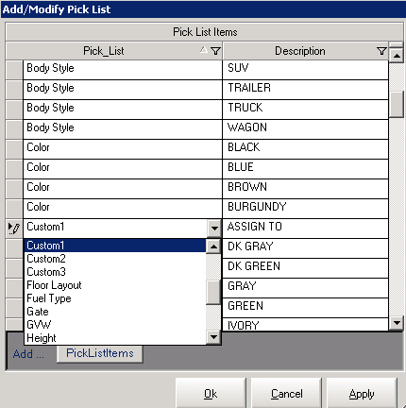

Click on the Add PickListItems button, a blank line will appear, use the drop down list to add an item, and then type the description of the entry. For example; choose Color from the drop down list and then type Black for the description. Repeat that process as many times as necessary.
Custom 1, Custom 2, and Custom 3, allow you to customize the entry for the Internet tab. For example, Custom 1 can be change to Assign To. Type Assign to: with a colon after the name.

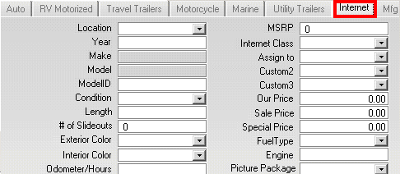

- The Changes Made button located on the Miscellaneous Screen – This displays all updates and changes Systems 2000, Inc. has made to the Infinity system. It is important to make sure you have a recent version of Infinity, as new features and alterations are constantly added to the software. Call Systems 2000, Inc.’s technical support staff for information on the latest updates for your system. (All updates are free of charge and are included in your monthly support payment).
- The Pocket PC Export button – This transfers all of the information about the inventory units to the pocket PC software (if applicable), allowing your salesmen to look up various units while walking the physical dealership lot.

- The Display all… buttons – These push all units tagged for display on the Internet to each designated website automatically.

- The three datasheets: Standard Datasheet, Utility Trailer Datasheet and Marine Datasheet allow you to view your inventory units in a spreadsheet format. You can sort and filter each datasheet to fit your specific needs. This information can also be copied into Microsoft Excel for analysis and custom report generation, or you can export the datasheet to different file. See example below:

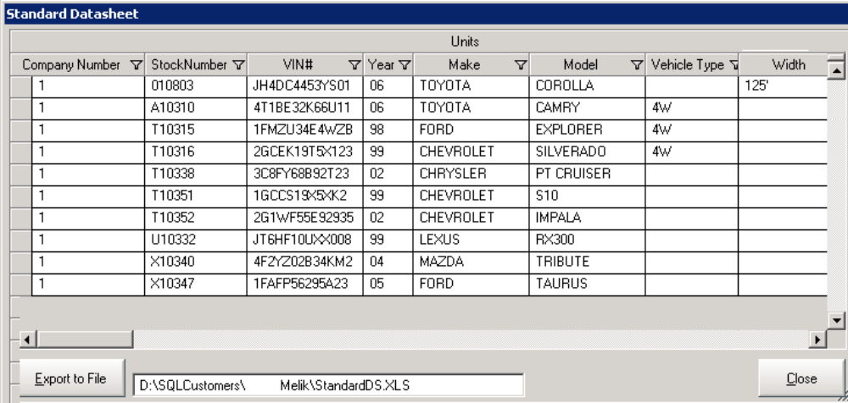

STANDARD DATASHEET

The buttons at the bottom of the Unit Inventory Main (IN. 1) screen allow users with the proper security rights to Add new or Delete existing inventory units.

To scroll to the Previous or Next unit, click the respective button.

- Dealer World – This button is for GM customers that would like to import their unit’s inventory into the Infinity system.

VIEWING / ADDING FINANCIAL INFORMATION ABOUT A UNIT

Under the Financial Tab

The Financial tab is a real time saver when used in conjunction with the Accounting Module. If granted security clearance to this tab, you can view and modify all the financial information for any selected unit. Infinity tracks every step in the process from the purchase of the unit to its sale, including whom you purchased the unit from and who you sold it to). You can also pre-set a percentage markup to be applied to each inventory unit and the Infinity system will automatically adjust the suggested selling price as the cost of the unit changes.

The Infinity system will calculate all charges and display the total cost of the unit. You can enter a flat package amount, a percentage or both. Once set, the system will regulate the cost to salesperson for reports, profits and commissions.

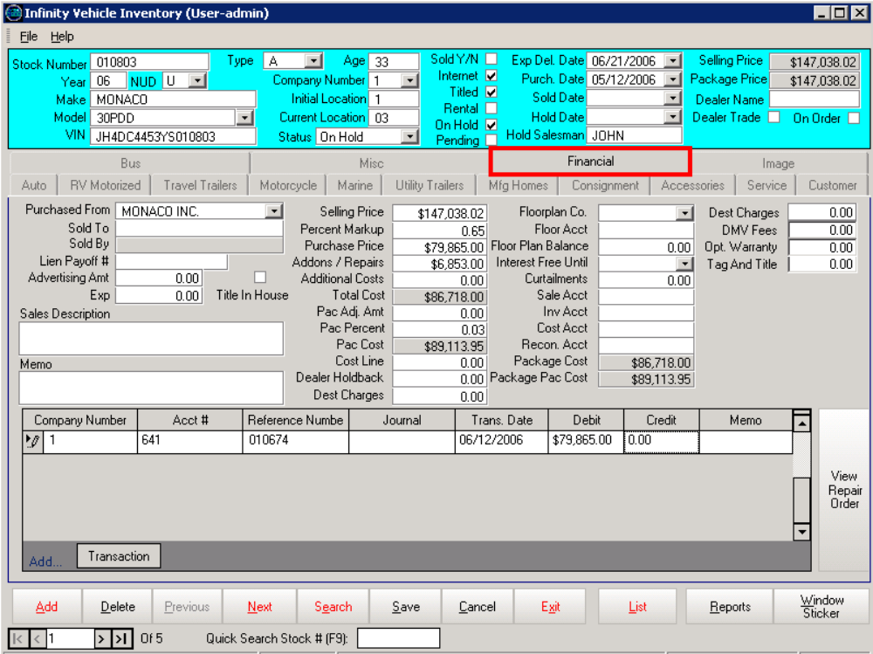

FINANCIAL SCREEN

If the selected unit is floor planned, the system will track the balances and curtailments. The Add Transaction button at the bottom left of the screen displays a detailed record of every accounting transaction that was posted regarding this unit.

If the transaction came from within the Service Department, you can click the View Repair Order button and Infinity will show the actual work order.

Fill in the appropriate information:
For example:

- Purchased From – If a unit is taken on a trade, this field will reflect the buyer’s name once the washout is performed from the Profit Accounting. For each new unit enter the appropriate information.

- Sold To – When washing out a deal, the purchaser’s name will be entered into this field.

- Lien Payoff Number – Enter the Lien Payoff number if applicable.

- Advertising Amount – Enter the amount spent on advertising this unit, if applicable.

- Exp – Enter any added expense amount related to this unit.

- Memo – Enter any additional comments or information you would like to record regarding this unit.

- Purchase Price, Add-Ons / Repairs, Additional Cost, and Total Cost – If either the “pending” box or the “consignment” box is not checked, the amount in Accounting will overwrite this figure.

- Selling Price – Infinity will automatically calculate the selling price from the purchase price and the percentage markup. However, if you prefer, you may enter the selling price manually using your keyboard.

- Percent Markup – Enter the percentage markup above the purchase price in this field. This figure will be used to calculate the selling price.

- Pac Adj Amt – If you have a flat Pac (The added amount above the cost) Adjustment Amount, enter it here. Otherwise, if your Pac is figured as a percentage of cost, enter the Pac percentage below in the Pac Percent field.

- Pac Percent – Enter the Pac percentage you use to calculate the Pac amount.

- Pac Cost – This is the unit cost after the Pac has been applied to the unit.

- Cost Line – Enter the minimum price that a unit can be sold at in this field.

- The Floor Plan Co – Select the floor plan company from the drop down list. The floor plan companies are entered in Accounting Module as suppliers.

- Floor Acct – Enter the GL account that Accounting refers to for the floor plan company you have selected from the drop down list.

- Floor Plan Balance – If your dealership is financing the unit, enter the amount.

- Curtailments – Enter the payment amount on the floor plan interest.

- Sale Acct, Inv Acct, Cost Acct, and Recon Acct (Reconditioning Account) – These account numbers should be set up by your Accounting Department during the start-up procedure. The amount of detail you wish to include in your financial statements will determine which account numbers go in these fields.

- Dest Charges – If a destination charge is applicable for the unit, enter the amount in this field.

- Opt. Warranty – Enter any optional warranty amount. (For reference use)

- DMV Fees – Enter the amount if applicable. (For reference use)

- Tag & Title – Enter the amount if applicable.

INPUTTING A UNIT

Inputting Basic Information about a Unit

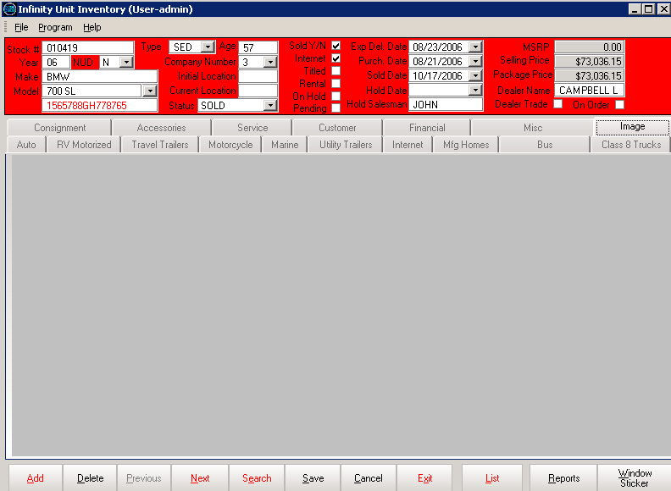
(IN. 2)

At the top of the Unit Inventory Main screen (IN. 2) is the basic information that is displayed for all unit types.

- Stock Numbers - Can be alphanumeric and up to 20 characters in length. Infinity can also be set to auto-number your stock. (To do this, refer to the Infinity Company Information manual)

- Enter the Year and unit Type or select it from the pick list, which can be set up to your dealership’s specifications. (Refer to the Miscellaneous section).

- In the NUD field, enter N for New, U for Used or D for Demo.

- Enter the Make, Model and the VIN number. Infinity will validate all 17 character identification numbers entered.

- Infinity automatically calculates the Age of the unit based on the purchase or trade-in date. Any unit whose age is older than 90 days is displayed in red. If the unit is sold, Infinity will calculate the number of days it took to sell the unit.

- Enter the Company Number – Enter your company number.

- Enter the Initial Location and the Current Location of the unit if you have multiple locations. The initial lot location is used to identify units that have been transferred to the current site.

- Choose the Status from the pick list, which can be set up to your dealership’s specifications (Refer to the Miscellaneous section). Each unit has a status field. As the status changes so does the background color of the screen.

- Sold – If the unit is sold, check this box. When washing out a deal in profit accounting, the sold box will be checked for the selling unit. Infinity never deletes sold units, each sold unit is displayed with a check in the sold box. This allows you to review your purchasing and sales history for as long as needed.

- Internet – Check this box for each unit you want to advertise on your dealership’s internet site. Individuals looking for a unit to buy online will not see the wholesale price.

- Titled – Check this box if you have received the title of the unit.

- Rental – If you are using the Infinity Rental module and the unit is available for rent, check the rental box.

- On Hold – Check this box if the unit is on hold.

- Pending – Check this box if you do not want Accounting to update the financial figures for this unit. This check mark also determines which units are waiting for a deal to be completed and profit to be acquired.

- The dates tracked for each unit are the Expected Delivery Date for the units in order, the Purchased Date or Traded in Date, and the Sold Date of the unit.

- Dealer Trade – Check this box if the unit is a dealer trade.

- On Order – Check this box if the unit is on order.

Inputting Detailed Information about a Unit

Under the Auto Tab
The Auto tab contains information that is applicable to automobiles. The second section of the screen allows you to fill out specific information about each unit including colors, prices, body styles, transmission types, etc.

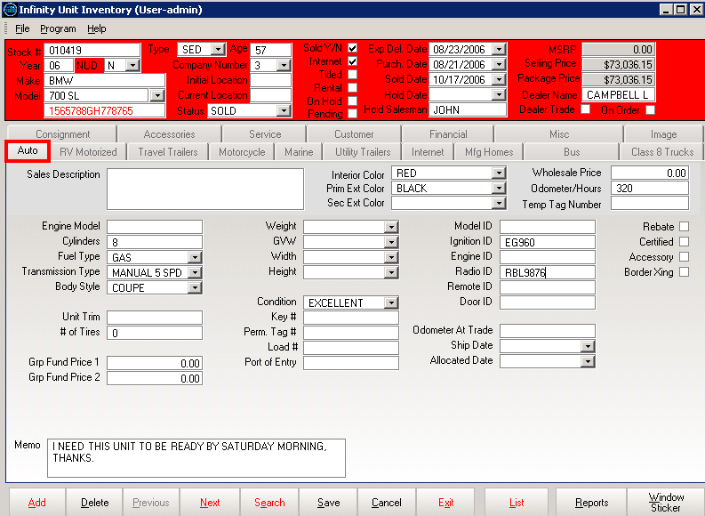

AUTO SCREEN

Fill in the appropriate information for each inventory unit:
For example:

- Interior Color – Choose from the drop down list. To modify the color list click on the Miscellaneous tab and then the Setup Unit Details Pick List button (see example for guidelines).
- Prim. Ext. Color – Choose the primary exterior color.
- Wholesale Price – Enter the wholesale price for the unit.
- Cylinders – Enter the number of cylinders for the unit.
- Body Style – Choose from the pick list.
- Odometer – Enter the number of miles on the odometer.
- Group Fund Price 1 / 2 – (For DaimlerChrysler dealerships franchise). Those prices deal with incentive.
- Ignition ID – In this field, enter the ignition ID if applicable.
- Fuel Type – Enter the fuel type for the unit (ex: Regular, Diesel, etc.)
- Transmission Type – Choose from the drop down list.
- Ship Date – Enter the date the unit was shipped from the warehouse or the distribution center.
- Allocated Date – Enter the date the unit was allocated and/or delivery work order was cut.
- Check mark the box Accessory, Rebate, Certified and Border Xing (Border Crossing; if the unit was bought outside the US) if applicable.
- Memo – Enter any additional comments or information you would like to record regarding the unit.

Under the RV Motorized Tab
The RV Motorized tab displays information applicable to RV dealerships, such as MSO Title Make and Coach serial number which are specific to RV unit inventory. On this screen, users may enter information applicable to each RV unit on the lot.

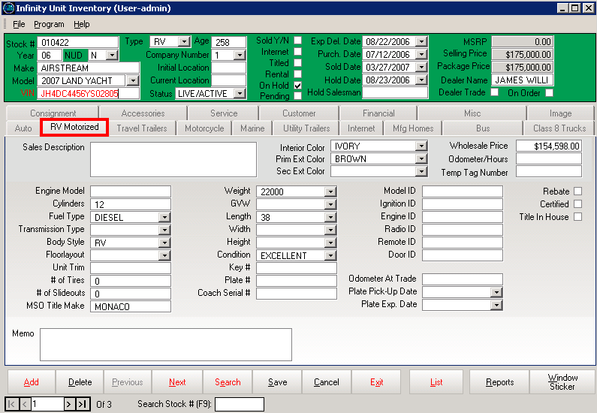

RV MOTORIZED SCREEN

Fill in the appropriate information:
For example:

- Interior Color – Enter the interior color.
- Prim. Ext. Color – Enter the primary exterior color.
- Wholesale Price – Enter the wholesale price.
- Length – Enter the unit length (ft.).
- MSO Title Make – Enter the manufacturer statement of origin title make.
- Coach Serial Number – Enter the Coach Serial number.
- Floor layout – Enter the appropriate floor plan such as 2 bedrooms, split plan if the unit is an RV. You may choose to use the floor plan layout codes supplied by the manufacturer.
- Fuel Type – Enter the fuel type to be used by the unit (ex: Regular, Diesel, etc.).
- Model ID – Enter the model ID number for the unit, if applicable.
- Memo – Enter any additional comments or information you would like to record regarding the unit.

Under the Travel Trailers Tab
The Travel Trailers tab displays information specific to travel trailer units such as the year, make, model and the engine of the tow unit.

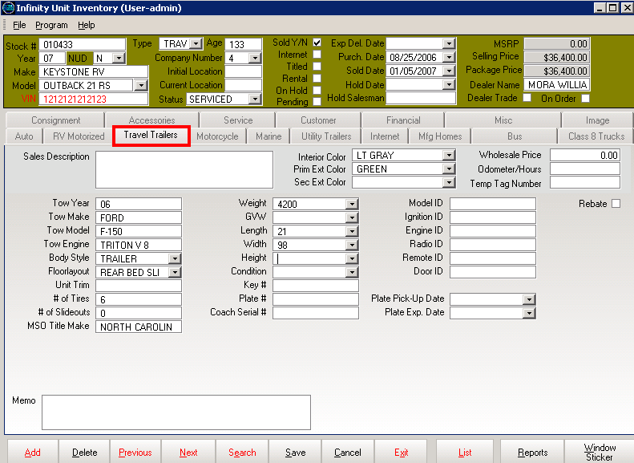

TRAVEL TRAILERS SCREEN

Fill in the appropriate information:
For example:

- Interior Color – Enter the interior color in this field.
- Prim. Ext. Color – Enter the primary exterior color of the unit.
- Wholesale Price – Enter the wholesale price of the unit.
- MSO Title Make – Enter the MSO Title Make description in this field.
- Length – Enter the length of the unit (ft.).
- Weight – Enter the weight of the unit (lb.).
- Floor layout – Enter the appropriate floor plan such as 2 bedrooms, split plan. You may choose to use the floor plan layout codes supplied by the manufacturer.
- GVW – Enter the Gross Vehicle Weight.
- Tow Vehicle Information – Enter the Year, Make, Model and Engine.

Under the Motorcycle Tab
The Motorcycle tab provides a screen for motorcycle and power sport dealerships to enter information specific to the units on their lots.

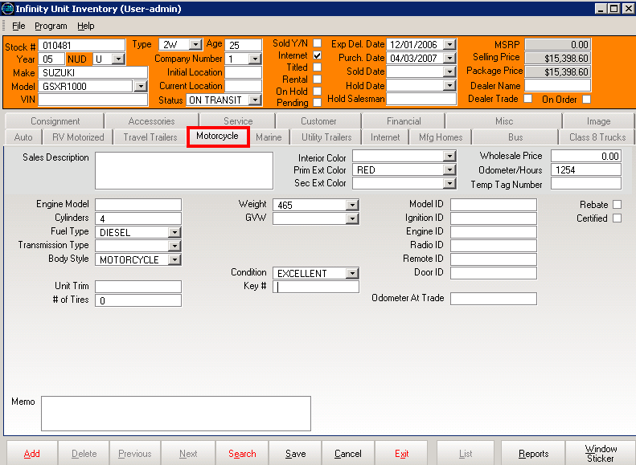

MOTORCYCLE SCREEN

Fill in the appropriate information:
For example:

- Prim. Ext. Color – Enter the primary exterior color.
- Wholesale Price – Enter the wholesale price for the unit.
- Odometer – Enter the number of miles on the odometer in this field.
- Cylinders – Enter the number of cylinders for the unit.
- Weight – Select the weight of the unit (lb.) from the drop down list.

Under the Marine Tab
For marine dealerships, inventory control can be quite a challenge without the appropriate software. Infinity is capable of recoding information for a boat, a trailer, and two individual motors. Although this information is all recorded under the same unit, Infinity allows you to have the option for boats, motors, and trailers to be stocked

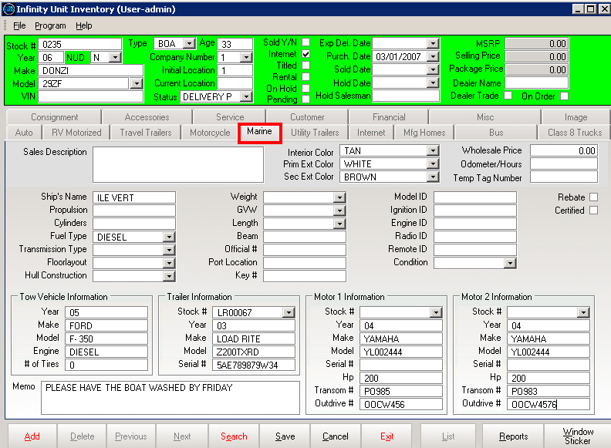

MARINE SCREEN

Fill in the appropriate information:
For example:

- Interior Color – Select the interior color of the unit from the drop down list.
- Prim. Ext. Color – Select the primary exterior color from the drop down list.
- Wholesale Price – Enter the wholesale price for the unit.
- Weight, Length – Select the weight (lb.) and the length (ft.) from the drop down lists.
- Fuel Type – Enter the fuel type applicable to the unit in this field.
- Ships Name – Enter the name of the ship which appears on all registration.
- Official Number – Enter the official number for the unit in this field.
- Trailer Information – Stock Number, Year, Make, Model, Serial Number
- Motor 1 Information – Enter the Stock Number, Year, Make, Hp (Horse Power), Transom Number, and Outdrive Number for Motor 1 of the unit.
- Motor 2 Information – Enter the Stock Number, Year, Make, Hp (Horse Power), Transom Number, and Outdrive Number for Motor 2 of the unit.
- Tow Vehicle Information – Enter the Year, Make, Model, and Engine for the tow vehicle.

Under the Utility Trailers Tab
Utility, Cargo and Horse Trailer dealers can manage their inventory effectively since Infinity allows for the input and tracking of hitch size, axles, breaks, construction, and gross vehicle weight.

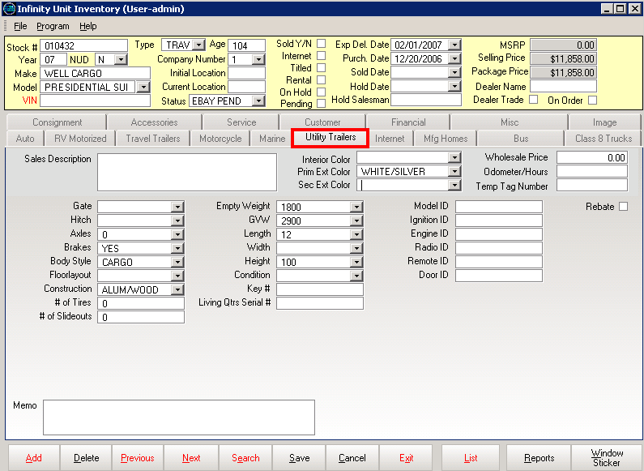

UTILITY TRAILERS SCREEN

Fill in the appropriate information:
For example:

- Colors – Enter the primary exterior color, secondary exterior color, and interior color for the unit.
- Wholesale Price – Enter the wholesale price of the unit.
- Body Style – Select the body style of the unit from the drop down list.
- Hitch /Axles – Select the appropriate response from the drop down lists.
- Brakes – Select “yes” if the trailer has brakes; select “no” if the trailer has no brakes.
- Construction – Select the material type composing the trailer.
- Gate – Select “yes” if the trailer has a gate; select “no” if there is no gate on the trailer.
- GVW – Gross Vehicle Weight (lb.).
- Length – Select the length of the trailer (ft.) from the drop down list.
- Width – Select the width of the trailer (ft.) from the drop down list.
- Height – Select the height of the trailer (ft.) from the drop down list.

Under the Mfg Homes Tab

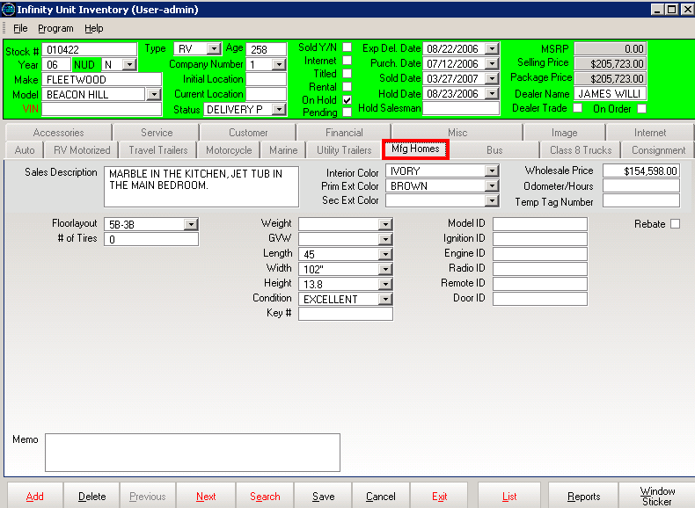

MANUFACTURED HOMES SCREEN

Fill in the appropriate information:
For example:

- Interior Color – Enter the interior color of the unit.
- Prim. Ext. Color – Enter the primary exterior color of the unit.
- Wholesale Price – Enter the wholesale price of the unit.
- Width – Select the width of the unit (inches).
- Height – Select the height of the unit (feet).
- Length – Select the length of the unit (feet).
- Floor layout – Enter the appropriate floor plan for the unit such as 2 bedrooms, split plan. You may choose to use the floor plan layout codes supplied by the manufacturer.

Under the Bus Tab
The Bus tab displays information specific to buses such as capacity, number of tires and chassis.

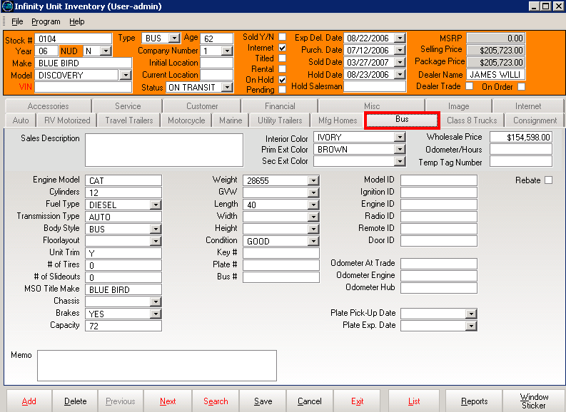

BUS SCREEN

Fill in the appropriate information:
For example:

- Interior Color – Enter the interior color of the unit.
- Prim. Ext. Color – Enter the primary exterior color of the unit.
- Wholesale Price – Enter the wholesale price of the unit.
- MSO Title Make – Enter the make name of the unit in this field.
- Bus Number – Enter the bus identification number for the unit in this field.
- Transmission Type – Enter the transmission type for the bus in this field.
- Capacity – Enter the capacity for the bus in this field (ex: number of passengers).
- Chassis – Select the chassis type from the drop down list.
- Length – Select the length of the unit (ft.) from the drop down list.
- Weight – Select the weight of the unit (lb.) from the drop down list.
- Fuel Type – Select the fuel type for the unit (ex: Diesel) from the drop down list.
- Cylinder – Enter the number of cylinders for the unit in this field.
- Brakes – Select YES if the unit has brakes; select NO if the unit does not have brakes.

Under the Class 8 Trucks Tab
The Class 8 Trucks tab displays information specific to buses such as capacity, number of tires and chassis

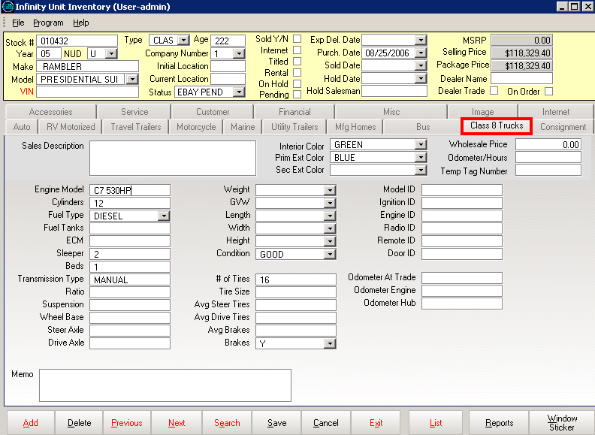

Fill in the appropriate information:
For example:

- Interior Color – Enter the interior color of the unit.
- Prim. Ext. Color – Enter the primary exterior color of the unit.
- Wholesale Price – Enter the wholesale price of the unit.
- ECM – Electronic control module
- Sleeper – Enter the bus identification number for the unit in this field.
- Transmission Type – Enter the transmission type for the bus in this field.
- # of Tires – Enter the number of tires on the unit, as well as the tires size
- Length – Select the length of the unit (ft.) from the drop down list.
- Weight – Select the weight of the unit (lb.) from the drop down list.
- Fuel Type – Select the fuel type for the unit (ex: Diesel) from the drop down list.
- Cylinder – Enter the number of cylinders for the unit in this field.
- Brakes – Select YES if the unit has brakes; select NO if the unit does not have brakes.
- Odometer at Trade, Odometer Engine, and Odometer Hub – Enter the appropriate mileages.

Under the Consignment Tab
If the unit being displayed is a consignment unit, check the Consignment box; enter the Consigner’s Name and the Consignment Amount in the third section of the screen.

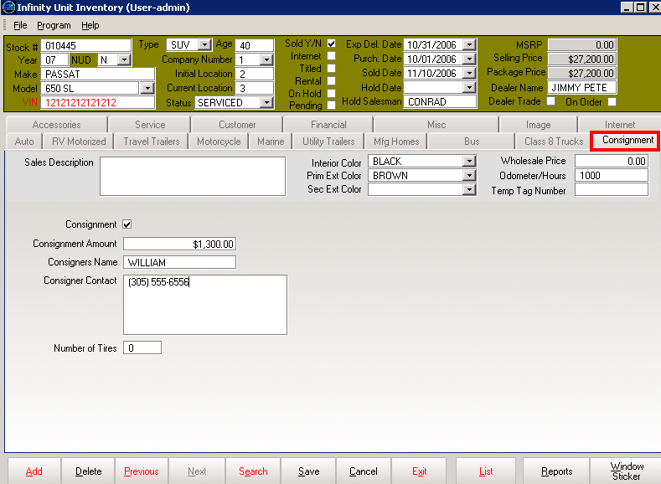

CONSIGNMENT SCREEN

You can enter any description of the unit in the Sale Description box.

Under the Internet Tab
The Internet tab shows the most common information about the unit that will be displayed on your web site.
In order for the unit to be viewed on your web site check the “display on Internet” option.
A program call Vehicle Export will transfer your inventory data to your web master if the Display on Internet box is checked. This program is a link between your unit inventory and your web master. (This is a scheduled task which runs daily).

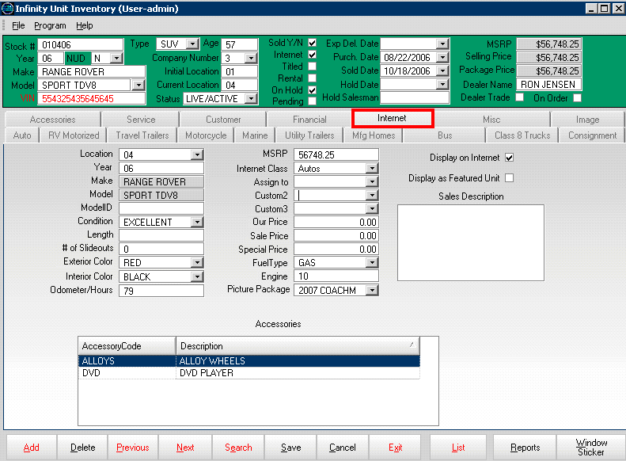

If the unit is checked as a featured unit, it will be displayed on the home page of your site. You can also enter any prices you want displayed along side of each unit.

Fill in the appropriate information:
For example:

- Year – Enter the year of the unit.
- Make, Model – Enter the make and model of the unit.
- Condition – Enter the condition of the unit.
- Interior Color – Enter the interior color of the unit.
- Prim. Ext. Color – Enter the primary exterior color of the unit.
- MSRP – Enter the MSRP of the unit.
- Custom 1, Custom 2, Custom 3 – Those 3 fields can be customize (See Miscellaneous tab chapter)
- Our Price – Enter your price of the unit.
- Sale Price – Enter the sale price of the unit if applicable.
- Picture Package – This is a standard list of different Makes and Models. If you see a make and model corresponding to your unit, select it, and standard pictures of that unit will be displayed on your web site.
- Display as Featured Unit – Check this box if you want that specific unit to be exhibited as a featured unit on your web site.

VIEWING OR ADDING ACCESSORIES TO A UNIT

Under the Accessories Tab
The Accessories tab displays all installed options and accessories for the unit. Accessory codes can be pre-loaded and selected from the drop down list. Any accessories that are not factory installed can be set to update the package price of the unit.

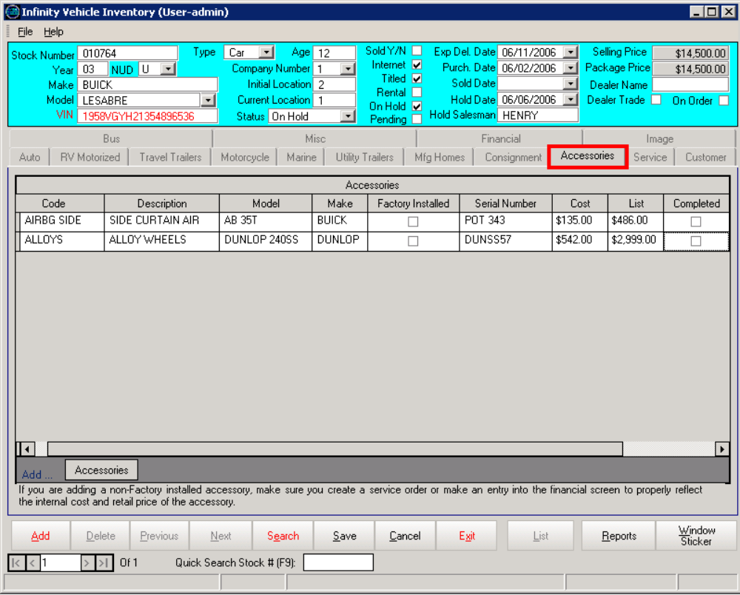

ACCESSORIES SCREEN

Note: If the accessory codes are not pre-loaded, click the Add Accessories button and fill in the information.

If the accessory is factory installed, check the Factory Installed box.

If the accessory is added to the unit, check the Completed box when the installation is finished.

VIEWING UNIT CUSTOMER HISTORY INFORMATION

Under the Customer Tab
The Customer tab displays information related to the buyer.
Customer basic information is recorded with each sale.
Infinity’s customer tab displays from whom you purchased the unit and to whom you sold it. You can also track the trade stock number, deal number, and initial prospect number.

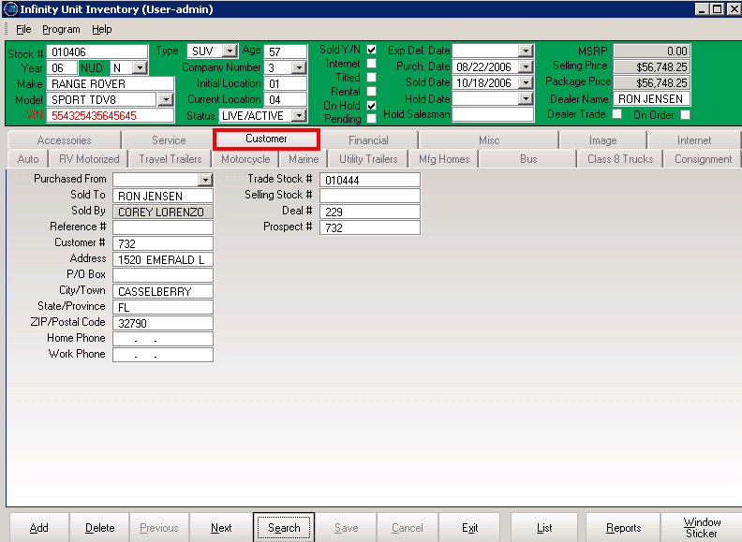

CUSTOMER SCREEN

Fill in the appropriate information:
For example:

- Purchased From – If a unit is taken on a trade, this field will reflect the buyer’s name once the washout is performed from the Profit Accounting. For new unit enter the appropriate information.
- Sold To – When washing out a deal, the purchaser’s name will be entered into this field.

- Sold By – Enter the name of the salesmen who sold the unit in this field when the deal is closed out.
- Reference Number, Customer Number
- Address, City/Town, State/Province, Phone Number
- Trade Stock Number, Selling Stock Number, Deal Number – Those numbers are transferred automatically from the Deal Desking Module, when the customer is entered in a Quote or in a Deal.

VIEWING IMAGE OF THE UNIT

Under the Image tab
You can display all types of images.
With Infinity you can store and display unlimited photos and videos including the latest technology of 360 video tours of your inventory.

Available for a subscription, Systems 2000, can provide you with picture bundles and 360 video tours of from our library of unit photos. Once the subscription is purchased you only need to select the picture bundle for the displayed unit and Infinity populates the left pane with all the available photos contained in the bundle.

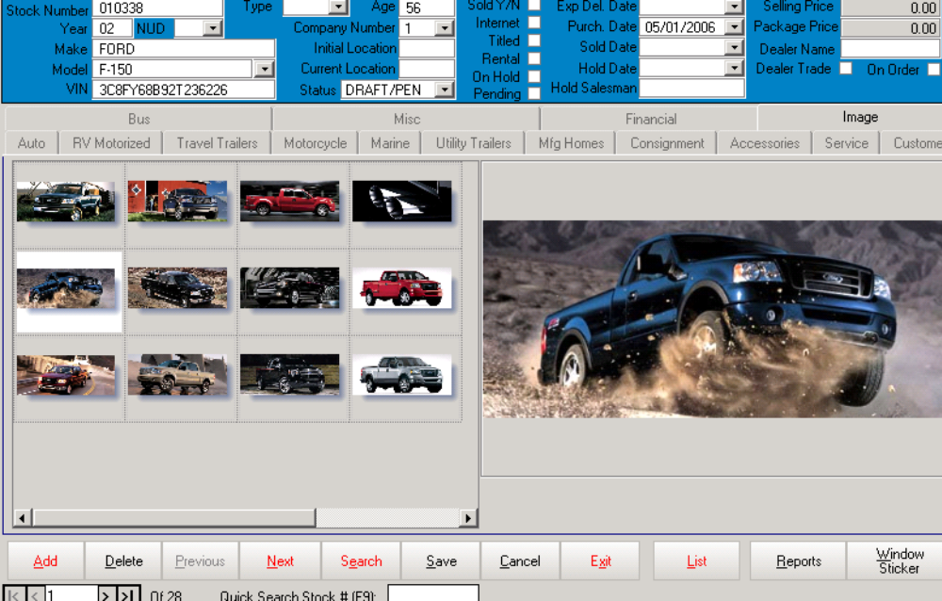

- First, acquire pictures of the unit. Create a folder for each unit using the stock number as the folder name, for example: 010338 is the folder name for the unit above.

- Second, put the folder into the Infinity Vehicles folder and the Infinity system will pull out the images automatically. (See above images)

VIEWING SERVICE REPAIR INFORMATION

Under the Service Tab
You can view all services performed on the unit as well as the Invoice Number, the Date, and the Technician that performed the repair.

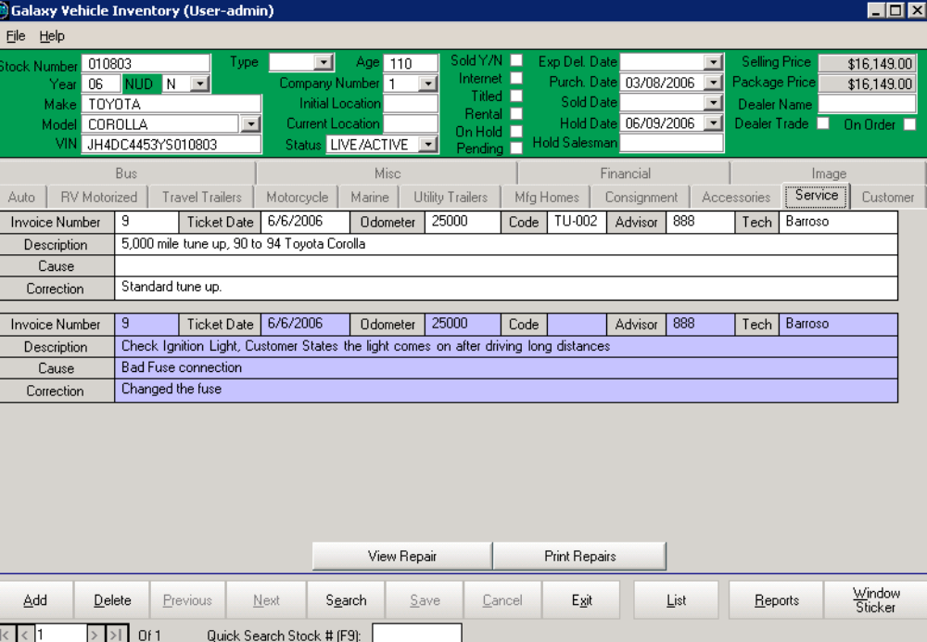

To view each service in detail, highlight the repair by clicking on it, and then click the View Repair button.

The Service Repair screen will appear.

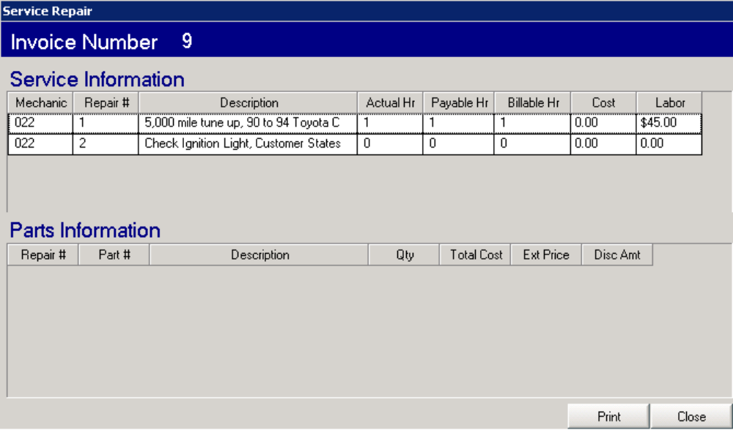

UNIT INVENTORY SEARCH

Use the Search button located at the bottom of the main screen (IN. 1) if you want to filter and display information by using search criteria.

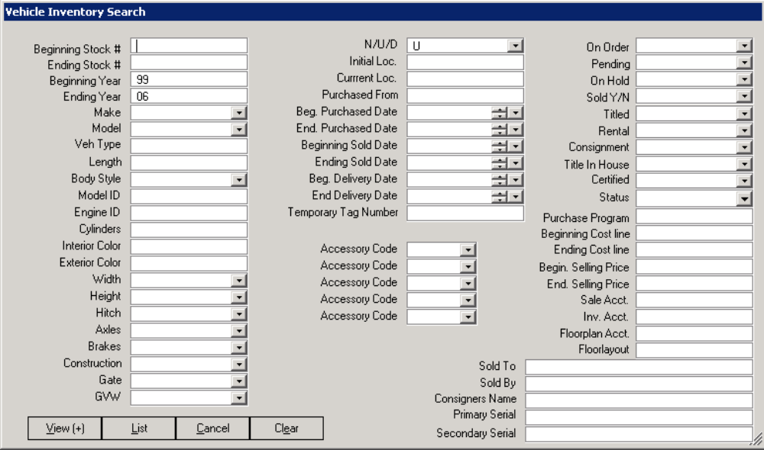

VEHICLE INVENTORY SEARCH SCREEN

You can enter as much or as little information needed to perform your search. Click the List button to view result (see below).

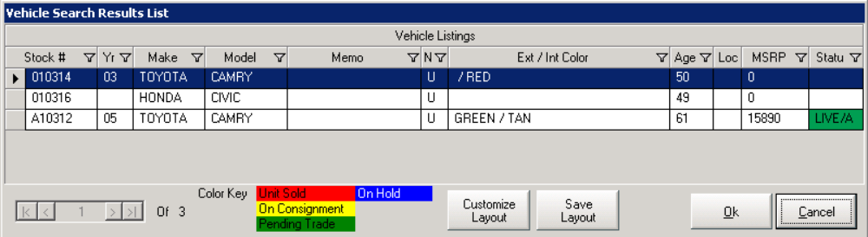

Highlight the unit of your choice, and then click the OK button for more details about the unit.

To customize the layout of the Vehicle Search Result List, click the Customize Layout button, the Field Chooser screen will appear. Check the fields you would like to see on the Vehicle Search Result List screen. Click the Save Layout button to save the arrangement for future view.

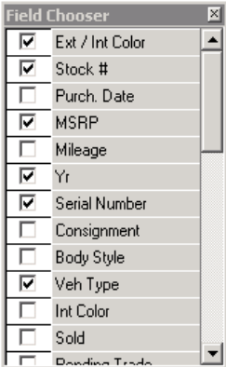
REPORTS & WINDOW STICKERS

The Infinity Unit Inventory module allows you to access directly the Infinity Reports module.
On the Infinity Unit Inventory Main screen, click the Reports button.

This action takes you to the Infinity Reports screen (See below).

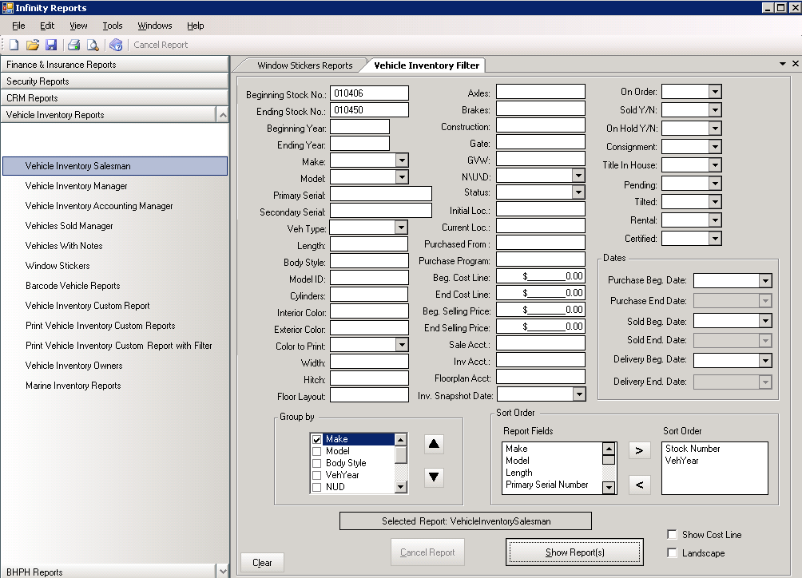

1
2
3

Choose from the menu located on the top left of the screen what type of report you are looking for; Finance & Insurance Reports, Security Reports, CRM Reports, and Vehicle Inventory Reports.
The Vehicle Inventory Reports are classified into three categories: Salesman Reports, which do not display costing figures, Manager Reports that display packed costs or cost to sales reports, and Accounting Reports, which display actual accounting, costs.

- Use the filters to narrow your search
- Check the Landscape box for different view of the report (horizontal view versus vertical view)
- Check the Show Cost Line on the report to view the minimum sale price of the unit.

The Vehicle Inventory Reports allows you to design your own custom reports, using the Group by and the Sort Order fields.
Select from the drop down list the Group By items; highlight the desired Report Fields by clicking on them. Move the selected fields from the Report Fields box to the Sort Order box by using the single arrow.

Click the Show Report(s) button when finished.
(See example on the next page)
Example: Vehicle Inventory Salesman report:

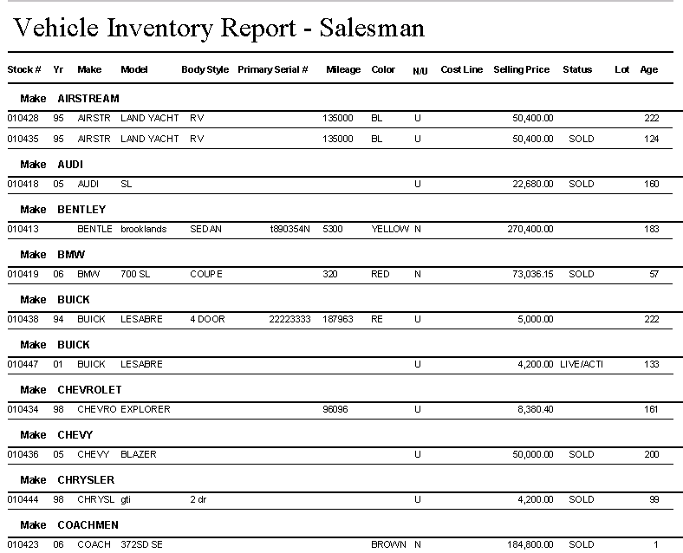

The Window Sticker button allows you to print an up-to-date window sticker for each unit. The system will print either to plain paper or to your specified letterhead.

Click the Window Sticker button and the following window will appear:
Infinity offers you a diversified panel of window stickers for your units

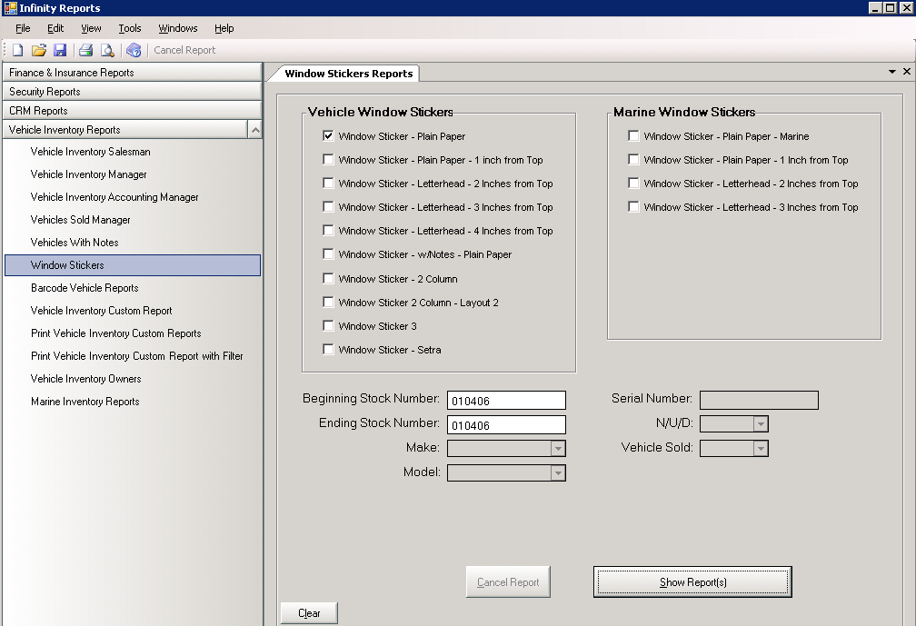

This menu provides you with available options for printing your stickers, as well as, special stickers for marine units.

The menu also allows you to print Barcodes by clicking on the appropriate button.

Example; window sticker on a plain paper.



