SYSTEMS 2000
INFINITY
DEAL DESKING
USER MANUAL

CONTENTS

START-UP 3

COMPANY INFORMATION - (Refer to the Company Information Set-Up Manual) 3

SALES EMPLOYEE INFORMATION - (Refer to the Employee Information Set-Up Manual) 3

ACCOUNTING SET-UP 3
If you are using the Infinity Accounting Module, you must enter all the GL accounts into the accounting system and then match them to the accounts in the Accounts Summary Set-up in this manual.

FINANCIAL SOURCES SET-UP 4
All finance deals must be assigned to a financial institution; therefore, you need to enter all your financial institutions information. This process will create a drop down list in the Infinity deal desking system for faster deal processing.

LIEN PAYOFF COMPANY INFORMATION SET-UP
Enter all your Lien Payoff companies’ information. This process will create a drop down list in the Infinity deal desking system for faster use of the system.

CREDIT SOURCES SET-UP 7
If your dealership intends to sell Credit Life or Accident & Health Insurance, you need to enter all your insurance companies’ information. This process will create a drop down list in the Infinity deal desking system for faster use
of the system.

CREDIT LIFE RATES SET-UP 9
If your dealership sells credit life insurance, you will have to set-up the credit life rates charged by the insurance companies for the system to work efficiently.

HEALTH RATES SET-UP 11
If your dealership intends to sell Accident & Health Insurance, you will have to set-up the accident and health rates charged by the insurance companies for the system to work efficiently.

WARRANTY SOURCES SET-UP 12
If your dealership intends to sell warranties, all of them must be assigned to a warranty company; therefore, you need to enter all your warranty companies’ information. This process will create a drop down list in the Infinity deal desking system for faster deal processing.

SALES TAX RATES SET-UP 13
The Infinity system allows you to adjust state, county, and city Sales Tax Rates when necessary through the set-up.

ACCOUNTING DEFAULTS SET-UP 15
The Infinity system allows you to enter standard account numbers for the main transactions for each company; these will be your default GL account numbers for each type of transaction.

ADD / MODIFY STATUS SET-UP 17
The Status field relates to the description of the deal. For example; Open for an open deal, Cancelled for a cancel deal…The system allows you to enter any description of your choice.
This process will create a drop down list in the Infinity deal desking system for faster use of the system.

ADD / MODIFY FEES SET-UP 17
The Fee fields relate to any fees your dealership charges (Bank Fees, Waste Tire Fee, Documentation Fees…)
The system allows you to set-up an unlimited number of fees.
This process will create a drop down list in the Infinity deal desking system for faster use of the system.

ADD / MODIFY PRODUCTS SET-UP 18
The Product fields relate to any extras your dealership adds to the unit (Rust proofing, Paint Sealant,
Fabric Treatment …)
The system allows you to set-up an unlimited number of products.
This process will create a drop down list in the Infinity deal desking system for faster use of the system.

DEAL PRE-SETS SET-UP 19
The Infinity Deal Desking system allows you to pre-set default values for different deals. For example; for different States, Counties, Units type like RV, Truck, Car, as well as for different finance companies…

INPUTTING DEALS 21

START A DEAL ( To change a Quote to a Deal ) 22

ENTER A BUYER 24

CHOOSE A VEHICLE 25

ENTER A TRADE 26

THE QUOTE SCREEN 27

ENTER EMPLOYEES ON A DEAL 32

ENTER EMPLOYEES COMMISSIONS ON A DEAL 33

ENTER TAXES 34

LOOK AT FINANCIAL FIGURES 35

ADD ACCESSORIES OR PARTS TO A UNIT 36

LOOK AT THE FINANCIAL PROFIT FOR A DEAL 37

LOOK AT THE SALE PROFIT FOR A DEAL 38

ENTER THE CUSTOMER INSURANCE INFORMATION 39

SEE THE HISTORY OF THE DEAL 40

SHOW A CUSTOMER THE DEAL 41

PRINT CONTRACTS AND FORMS 42

CLOSE OUT A DEAL 45

SYSTEMS 2000
INFINITY
DEAL DESKING
USER MANUAL

START-UP

Welcome to the Systems 2000 Infinity Deal Desking User Manual.

Infinity Deal Desking system is the link between Sales Prospecting and Finance & Insurance. It allows your dealership employees to generate deals, create quotes, figure gross profit, commissions, and print contracts & insurance forms as well as individual state forms.

WHAT YOU SHOULD HAVE BEFORE STARTING

- Company Information (e.g. Address, Phone / Fax Numbers, Sales Tax Rate ...)
- Warranty Company Information (e.g. Name, Address, Rates, Tables...)
- Insurance Company Information (e.g. Name, Address, Rates, Tables...)
- Employee Information (e.g. Name, Address, Phone Numbers, Employee Numbers ...)
- All Forms and Contracts sent to Systems 2000, Inc. and programmed
- OKI DATA printer 320 or 321

For directions on entering the required start-up data, refer to the Company & Employee Information Set-Up Manual.

ACCOUNT SET-UP

If you are using the Accounting Module, enter all of the GL accounts into accounting and then match them to the accounts in the Accounts Summary Set-up: (see the Accounting Defaults paragraph in this manual.)

FINANCIAL SOURCES
All finance deals must be assigned to a financial institution.

Add/Modify Financial Sources

On the Infinity Deal Desking Screen (See Below), click View - Modify then Finance Source.

Note: (Get familiar with the Deal Desking Screen; this is the Main Screen)

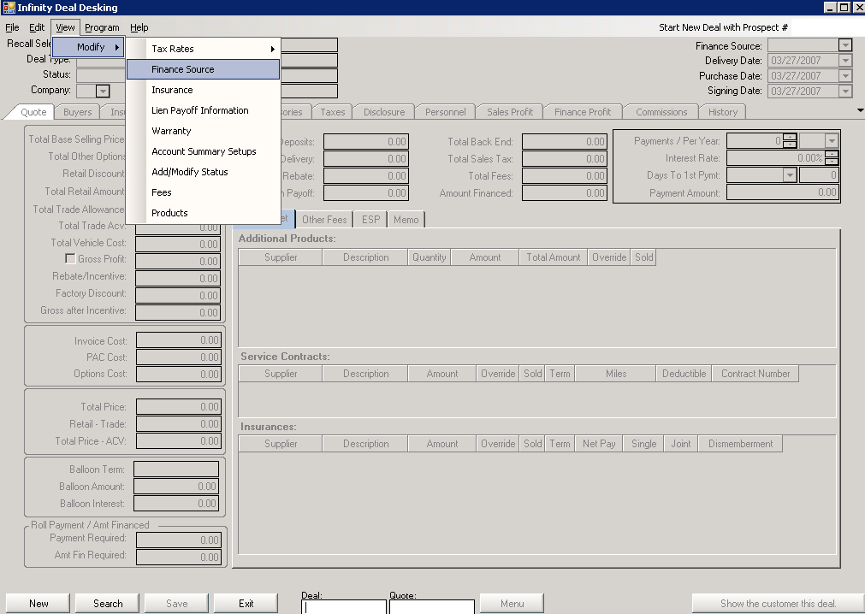
(DD. 1)
INFINITY DEAL DESKING SCREEN

This action takes you to the Finance Company Information screen (See next page)
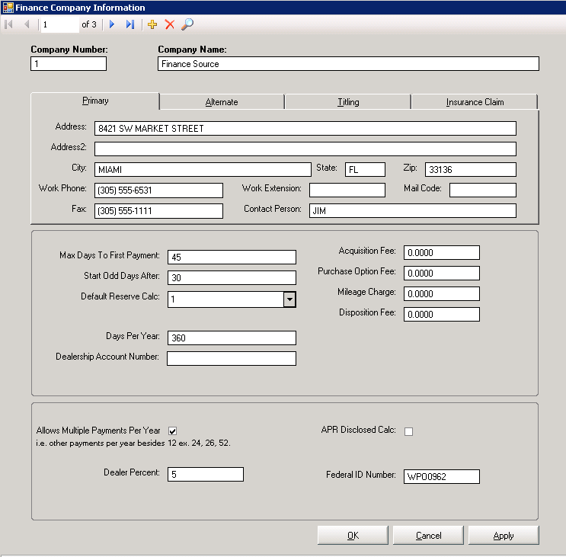
(DD. 2)
FINANCE COMPANY INFORMATION SCREEN

Enter the following information:

- Finance Company Number – The company number is used for reference as well as to differentiate between multiple finance companies. Enter the number given to the finance company by your dealership.
- Finance Company Name – Enter the full name of your finance company
- Street Address, City/Town, State, Zip Code – Fill the Alternate, Titling, and Insurance Claim addresses if they are different from the primary address by clicking on the appropriate tab.
- Phone Number / Fax Number / Contact Person
- Max Days to First Payment – If the bank accepts contracts with more than thirty days until the first payment is due: enter the maximum days allowed. If you enter this number as zero, the system will assume that it is an outside lien.
- Start Odd Days After – Most banks charge interest on every day after 30 days - otherwise known as “Odd Days Interest”. If a particular bank has a special finance deal, example: 40 days until the first payment is due at no interest, then you would set both the “Days to First Payment” and the “Start Odd Days After” fields to 40.
- Default Reserve Calculation – This field identifies the method used by a particular bank to figure out the dealership’s percentage of the interest. You can select the code from the drop down menu, which you can view by clicking on the down arrow to the right of this field. Please contact Systems 2000, Inc. if you need bank formulas programmed.
- Dealership Account Number – This is the number that a finance company has assigned to your dealership for reference purposes.
- Days Per Year – Most finance companies calculate on a calendar of 365 days per year; however, if this financial institute uses a federal calendar, enter 360 in the “Days per Year” field.

The Fees and Charges relate to lease units:
If your dealership leases units, enter the Fees and Charges added by your finance company.

- Acquisition Fee – Enter the amount that your finance company charges at the start of the lease.
- Purchase Option Fee – Enter the amount that your finance company charges when the customer wants to buy the lease unit.
- Mileage Charge – Enter the amount that your finance company charges when a customer goes over the mileage limit.
- Disposition Fee – Enter the amount that your finance company charges when the customer returns the lease unit.

- Allows Multiple Payments per Year – The box can be either check or unchecked depending on the calculation used by the financial institution, if checked the financial institution allows other payments per year besides 12, 24, 26 and 52.
- Dealer Percent – Enter the reserve percentage you would like your dealership to profit on a finance deal.
- Federal ID Number – Enter the finance company’s Federal ID number.
- APR Disclosed Calculation – The annual percentage rate box can be either checked or unchecked depending on the calculation used by a financial institution to calculate the bank service fee as an adjusted APR.
Most financial institutions calculate the APR disclosed as checked.

Click the + sign to add more companies

To return to the Deal Desking screen, click OK or click Cancel to void the changes.

Add/Modify Lien Payoff Company Information

Click View - Modify then Insurance on the Deal Desking Screen (DD. 1).

This action takes you to the Lien Payoff Bank Information Screen.

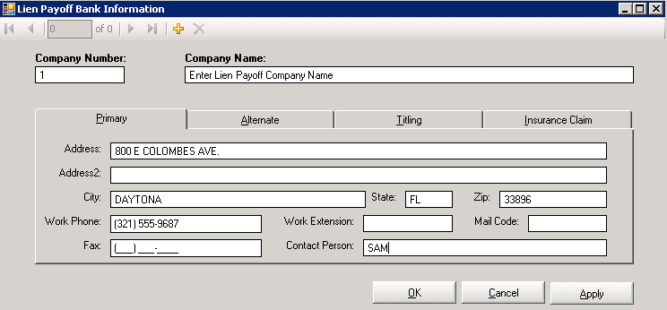

LIEN PAYOFF BANK INFORMATION SCREEN

Fill in all the necessary information. The entered information will be use throughout the system in a drop down format.
Click the Ok button when finished.

To verify your Insurance Rate Setups, contact Systems 2000, Inc.

CREDIT LIFE SOURCES
If your dealership intends to sell Credit Life or Accident & Health Insurance, all the companies’ information your dealership will use must be set-up.

Add/Modify Credit Life Sources

Click View - Modify then Insurance on the Deal Desking Screen (DD. 1).

This action takes you to the Insurance Company Information Screen.

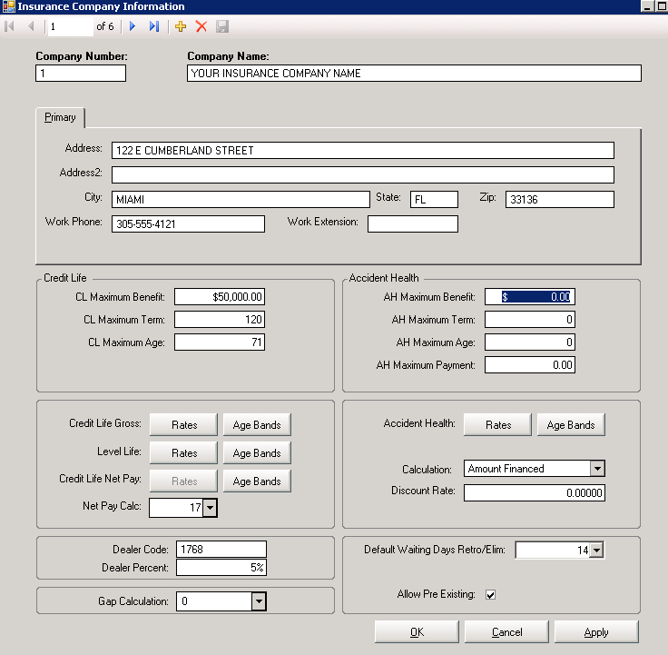
(DD. 3)
INSURANCE COMPANY INFORMATION SCREEN

Enter the following information:

- Company Number – The company number is used for reference as well as to differentiate between multiple insurance companies. Type the number corresponding to the company.
- Company Name – Enter the name of the Credit Life/Accident & Health Insurance Company.
- Street Address, City/Town, State, Zip Code
- Phone Number
Credit Life:
- CL Maximum Benefit – Enter the maximum amount the insurance company will pay.
- CL Maximum Term – Enter the maximum term of the insurance coverage.
- CL Maximum Age – Enter the maximum age of the customer at the end of the coverage.
- Net Pay Calc. – If you are selling net pay insurance, select the number from the drop down list.
Accident Health:
- AH Maximum Benefit – Enter the maximum accident health benefit (usually calculated as AH Maximum
Payment multiplied by maximum AH Term).
- Maximum AH Term – Enter the maximum term of the insurance coverage.
- Maximum AH Age – Enter the maximum age of the customer at the end of the coverage.
- AH Maximum Payment – Enter the maximum amount that the insurance company will pay for every payment.
- Calculation – Enter “Amount Financed or Total Payments” depending on how the insurance company calculate the premium amount. Most companies use the Total Payments calculation.
- Discount Rate – Enter the discount rate given to your state by the insurance company if applicable. Certain states are given discount by the insurance company for the same coverage. For example, a company will give 3% discount to the state of Alabama, but will charge full price to the state of Florida for the same coverage.

Default Days Retro / Elim:
- For Default Days Retro – Enter the number of days the buyer has to be out of work before the insurance company will cover the customer payment due to an accident or illness.
- For Default Days Elim – Enter the number of days in the waiting period before the insurance cover the customer payment due to an accident or illness.
- Allow Pre Existing – Check this box if the insurance covers pre-existing conditions.

- Dealer Code – If the insurer has assigned your dealership a code number for reference purposes, enter it here.
- Dealer Percentage – Enter the percentage your dealership will make on the insurance premium.

- Gap Calculation – If you are selling net Gap insurance, select the calculation from the drop down list. Please contact Systems 2000, Inc. if you need bank formulas programmed.

Click the + sign to add more companies

To return to the Deal Desking screen, click OK or click Cancel to void the changes.

CREDIT LIFE RATES
If your dealership intends to sell credit life insurance, you will have to set-up the credit life rates charged by
the insurance companies.

Add/Modify Credit Life Rates

Click View – Modify then Insurance on the Deal Desking Screen. (DD. 1)

This action takes you to the Insurance Company Information Screen.

Under the Credit Life section, click the Rates button for the selection that you want to modify.

(DD. 3)
INSURANCE COMPANY INFORMATION SCREEN

Example: Click on the Credit Life Gross Rates button.

This action takes you to the Monthly Credit Life Rate screen. (See next page)

The monthly Credit Life rates are per $ 100.

Use this screen if your credit life insurance companies provide you with rate charts broken down by month.

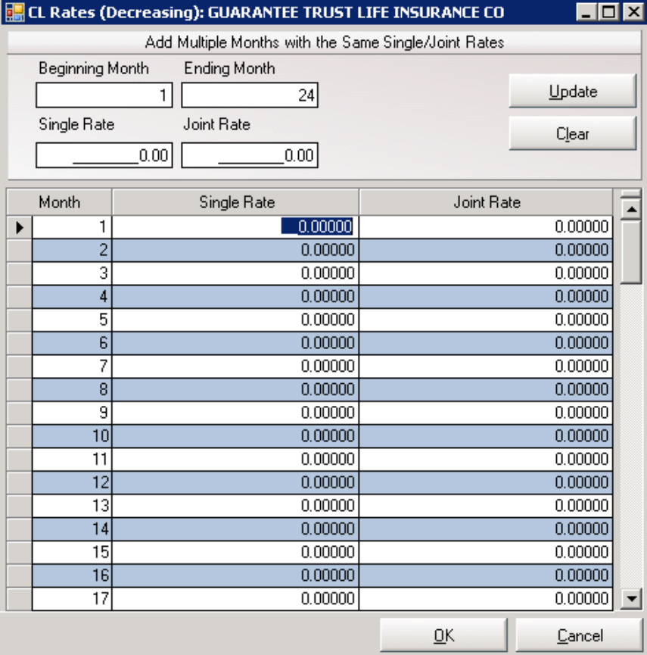
(DD. 4)
CREDIT LIFE RATES SCREEN

Enter the following information:

- Month – Enter the Beginning Month and the Ending Month. Infinity will increment the month numbers.
- Single Rate Per $100 – Enter the rate supplied by insurance company.
- Joint Rate Per $100 – Enter the rate supplied by insurance company.

To delete a rate, click the record selector box to the left of the record and press the Delete key on your keyboard.

If you have entered new information, it is important that you click the Update button before exiting this screen; otherwise your information will not be saved.

To return to the Deal Desking screen, click OK or click Cancel to void the changes.

The Age Bands button, located on the Insurance Company Information screen (DD. 3), displays the Age Bands screen allowing you to enter the age specific and disability rates. These rates are determined by the buyer’s age instead of the insurance term length. Your insurance companies provide you with the Age Bands chart.

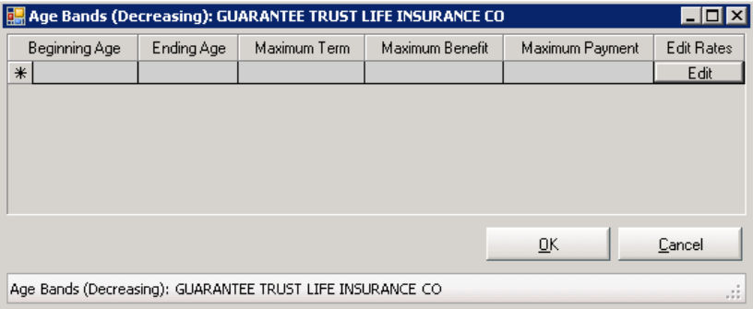
HEALTH RATES
If your dealership intends to sell Accident & Health Insurance, you will have to set up the Accident & Health
Rates charged by the Accident & Health Insurance Companies.

Add/Modify Health Rates

Click View - Modify then Insurance on the Deal Desking Screen. (DD. 1)

This action takes you to the Company Information Screen, (DD. 3)
Under the Accident Health section, click the Rates button next to Accident Health.

This action takes you to the Accident and Health Rates screen.

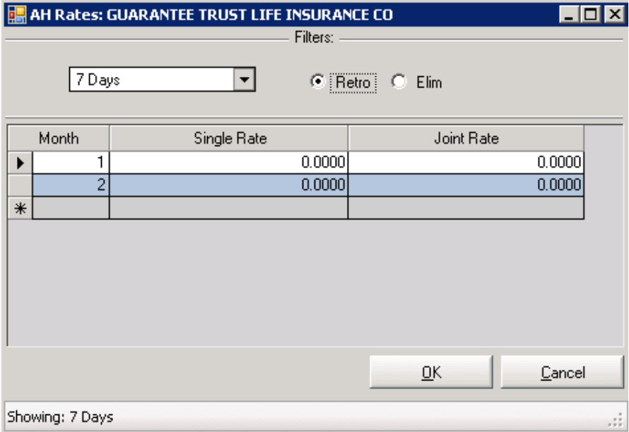
(DD. 5)
ACCIDENT HEALTH RATES SCREEN

The Accident & Health Insurance Companies provide you with the charge per month for specific number of days Retro or Elimination for coverage purposes.

Enter the following information:

- Month – Enter the month and for each month the Single and the Joint Rate.
- 7-Day Single – Enter the rate supplied by insurance company.
- 7-Day Joint – Enter the rate supplied by insurance company.
- 14-Day Single – Enter the rate supplied by insurance company.
- 14-Day Joint – Enter the rate supplied by insurance company.
- 30-Day Single – Enter the rate supplied by insurance company.
- 30-Day Joint – Enter the rate supplied by insurance company.

Retro: the buyer has to be out of work at least the number of days you selected from the drop down list before the insurance company covers the customer payment due to an accident or illness.
Elim: the buyer has a waiting period of at least the number of days you selected from the drop down list before the insurance company covers the customer payment due to an accident or illness.
Click on one of these selections for each time period: (7, 14, 30...120 days)

NOTE: If an Accident & Health Insurance Company has two different rates for people under 55 and over 55, you will have to set up two separate companies on the system. You can use the same name and address but they will have different company numbers and different rate numbers.

To return to the Deal Desking screen, click OK or click Cancel to void the changes
WARRANTY SOURCES
If your dealership intends to sell warranties, the Warranty Company Information must be set up.

Add/Modify Warranty Sources

Click View - Modify then Warranty on the Deal Desking Screen. (DD. 1)

This action takes you to the Warranty Company Information Screen.

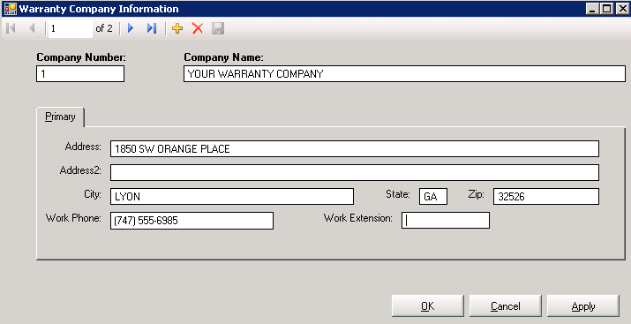
(DD. 6)
WARRANTY COMPANY INFORMATION SCREEN

Enter the following information:

- Company Number – The company number is used for reference as well as to differentiate between multiple warranty companies.
- Company Name – Enter the name of the warranty company.
- Street Address, City/Town, State, Zip Code
- Phone Number

Click the + sign to add more companies

To return to the Deal Desking screen, click OK or click Cancel to void the changes.

SALES TAX RATES
Infinity allows you to adjust State, County, and City Sales Tax Rates when necessary.

Add/Modify Sales Tax Rates

Click View - Modify then Tax Rates on the Deal Desking Screen. (DD. 1)

This action takes you to the State, County, or City Tax information Screen.

State Taxes – click State to add appropriate state tax information.

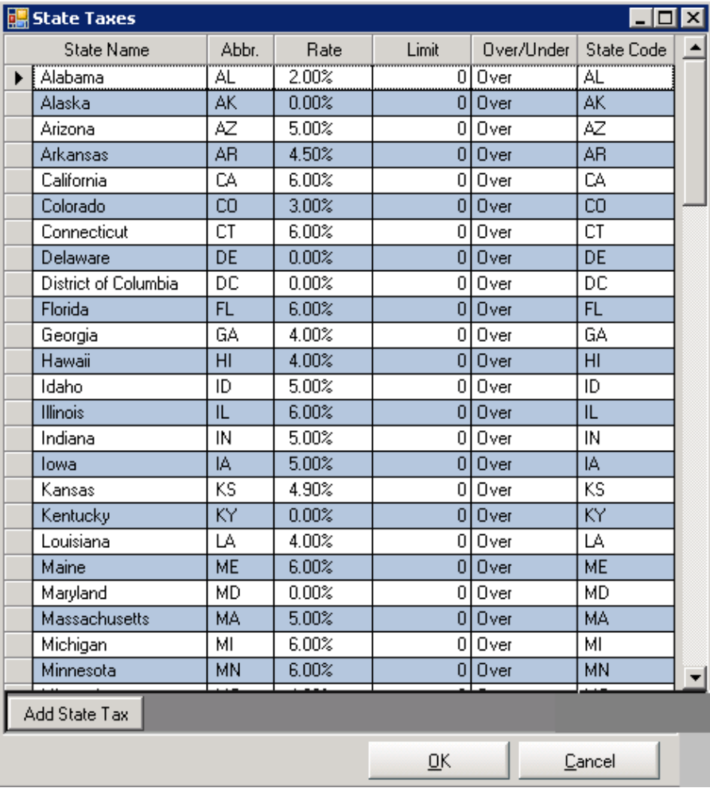
(DD. 7)

NOTE: Keep in mind that sales tax rates often change. Remember to verify the tax rates for each deal.

- State Name – The states name are automatically filled in for you.
- Sales Tax Rate – The rates are automatically filled in for you as a default, but it is your responsibility to maintain the current sale tax for each state. Enter a whole number for a percentage - for example, 6 for 6%.
- Sales Tax Limit – Some states and counties have a cap on their sales tax. For example, if your state
charges tax on all amounts over $10,000 you would enter “$10,000” in the sales tax limit field, and “O” for over in the Over/ Under field. If your state charges tax on all amounts under $10,000, enter “$10,000” in the sales tax limit field, and “U” for under in the Over/ Under field. If there is no cap, enter “0”.
- Over/Under – If you entered a sales tax limit then, enter “O” if tax is charged on amounts over that figure, or enter “U” if tax is charged on amounts under that figure. If there is no cap, enter “O.”

To return to the Deal Desking screen, click OK or click Cancel to void the changes.

County Taxes - click County to add appropriate county tax information.
Follow the same procedure as for state tax information.

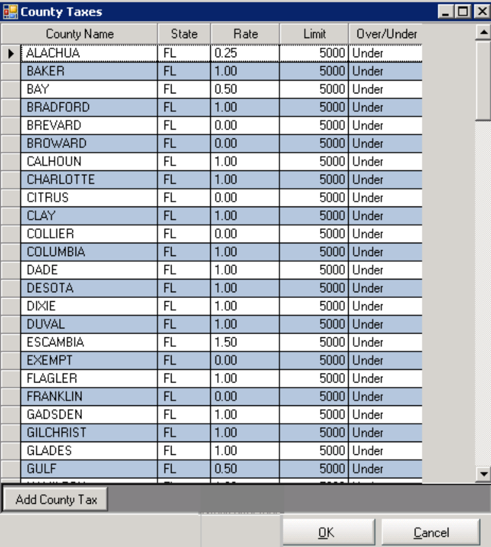
(DD. 8)

To add counties, click on the Add County Tax button.

To return to the Deal Desking screen, click OK or click Cancel to void the changes.

City Taxes - click this tab to add appropriate city tax information
Follow the same procedure as for state tax information.

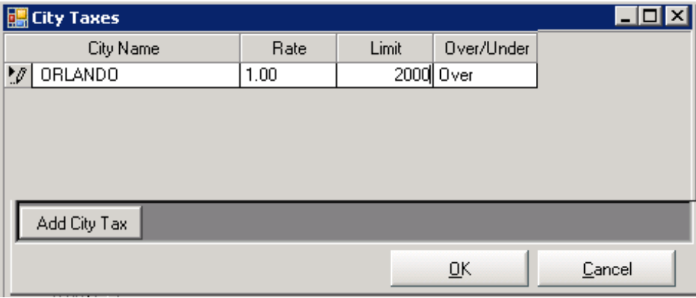
(DD. 9)

To return to the Deal Desking screen, click OK or click Cancel to void the changes.
ACCOUNTING DEFAULTS
Infinity allows you to enter standard account numbers for the main transactions for each company; these will be your default GL account numbers for each type of transaction.

Note: Accountants Should Perform the Accounts Setup.

Add/Modify Accounting Defaults

Click View - Modify - then Accounting Summary Setups on the Deal Desking Screen. (DD. 1)

This action takes you to the Account Summary Setups screen.

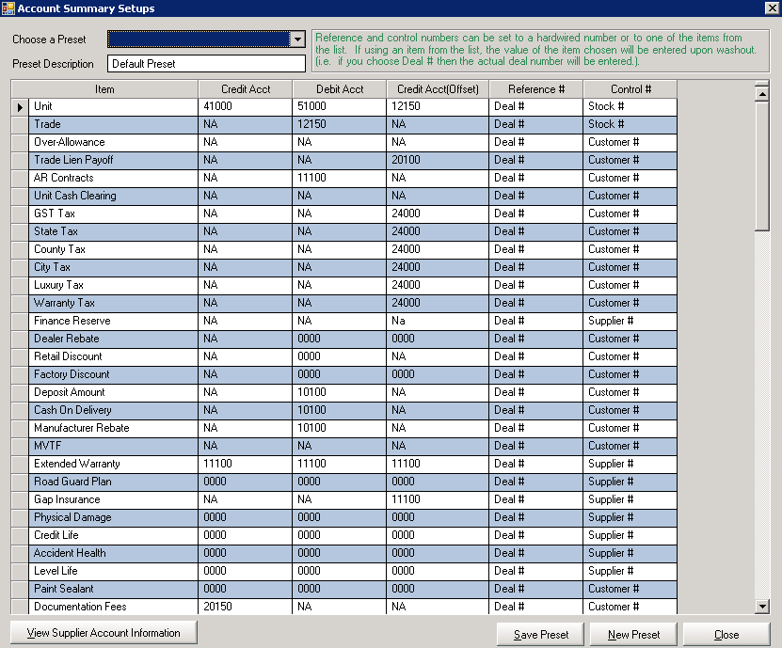
(DD. 10)
ΑCCOUNT SUMMARY SETUPS SCREEN

On this screen, you can:

- Add a Preset by clicking on the New Preset button, and then enter the Preset Description in the appropriate field.
- Click the Save Preset button when finished.
- View your Accounts Summary
- View your Supplier Account Information by clicking on View Supplier Account Information button (See screen on the next page)

Click the Save Preset button after each update.

To return to the Deal Desking screen, click Close.
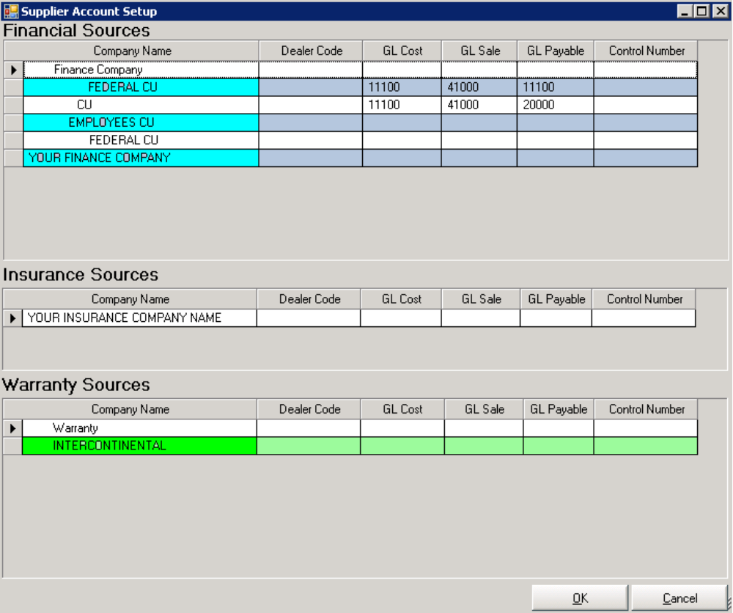
(DD. 11)
SUPPLIER ACCOUNT INFORMATION SCREEN

To return to the Deal Desking screen, click OK or click Cancel to void the changes.

This screen gives you an overview off all your Financial, Insurance and Warranty institutions with the corresponding GL accounts.

Add/Modify Status
The Status field relates to the description of the Deal. Example; Open for an open deal, Cancelled for a cancelled deal, ect.
Click View - Modify - then Add/Modify Status on the Deal Desking Screen. (DD: 1).

This action takes you to the Add/Modify Status screen.

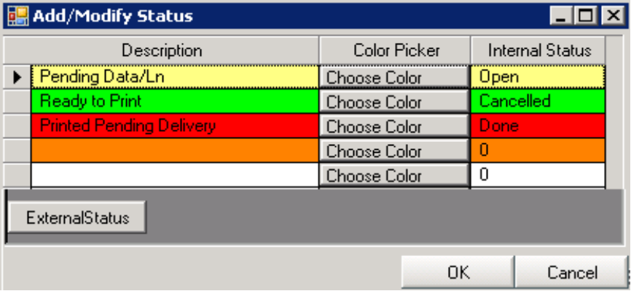
(DD. 12)
ADD/MODIFY STATUS SCREEN

To add a status, click the External Status button. A blank line will appear in the Description column. Type the description desired and choose a color to link to the description. Then in the Internal Status column, type what you want each description and color will represent on the Deal Desking screen as a choice of Status for a deal.
This allows for easier recognition of different Status type. The Status color will appear on the background screen of the deal.

To return to the Infinity Deal Desking screen, click OK or click Cancel to void the changes.

Add/Modify Fees

Click View - Modify - then Fees on the Deal Desking Screen (DD. 1)

This action takes you to the Fees screen.

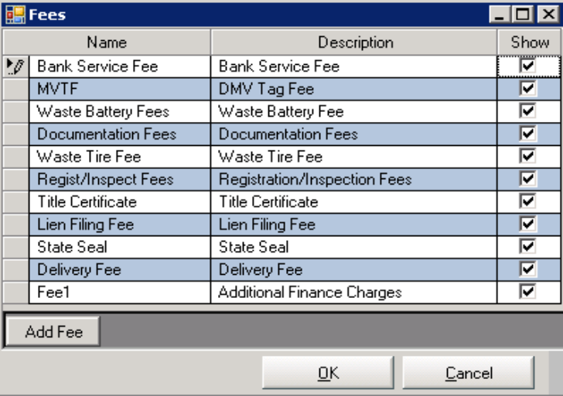
(DD. 13)
FEES SCREEN

To add a fee to the set-up, click the Add Fee button. A blank line will appear in the Name column. Type the desired description and then check the Show box in the show column.

To return to the Infinity Deal Desking screen, click OK or click Cancel to void the changes
Add/Modify Products
Products relate to any extras added to the unit. (Example; Rust Proofing, Paint Sealant…)

Note: Do not confuse products with accessories.

Click View - Modify - then Products on the Deal Desking Screen. (DD. 1)

This action takes you to the Products screen.

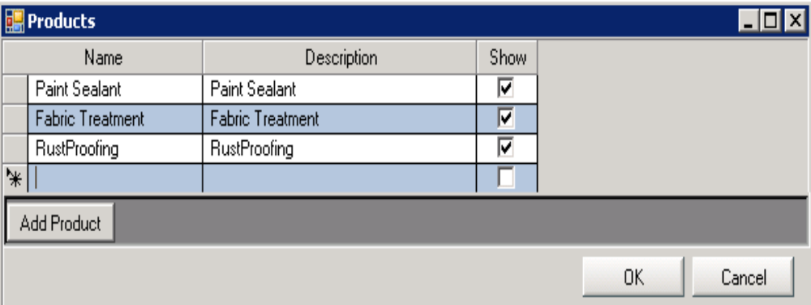

PRODUCTS SCREEN

To add a product to the set-up, click the Add Product button. A blank line will appear in the Name column.
Type the desired description of the product, and then check the Show box in the show column.

To return to the Deal Desking screen, click OK, or click Cancel to void the changes.

DEAL PRE-SETS
The Infinity Deal Desking system allows you to pre-set default values for different deals. For example; for different States, Counties, Units type like RV, Truck, Marine, as well as for different finance companies…

Add/Modify Deal Pre-sets

Click the New button in the Deal Desking Screen.

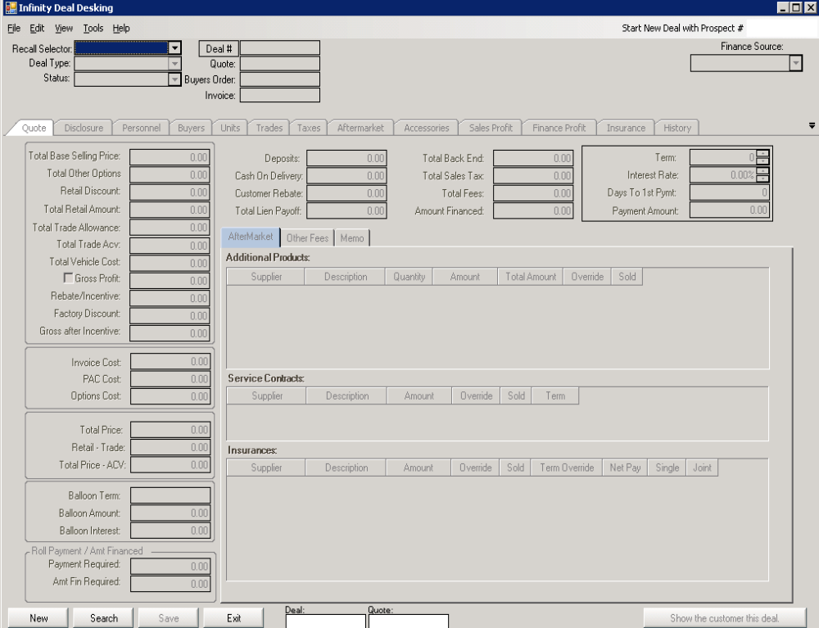

This action takes you to the Choose Preset screen.

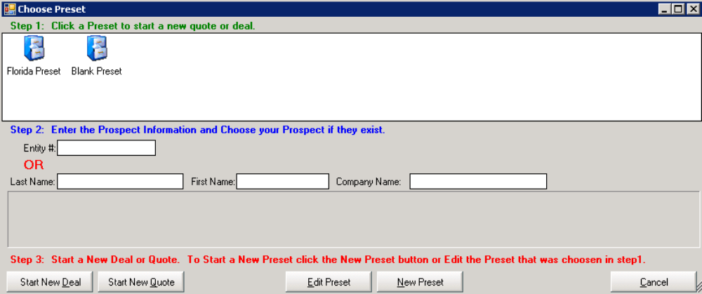

CHOOSE PRESET SCREEN

On this screen, you can Edit a Preset or start a New Preset.
To add a New Preset, click on the New Preset button. The Deal Desking screen (See next page) will appear, enter the preset name into the Deal # field (Example; Florida Preset). Enter the values you would like as your default values in the module (Pre-set the Florida Taxes, and your most use Financial companies…) and then click the Save button.
The new preset name will appear under Step 1 of the Choose Preset Screen.
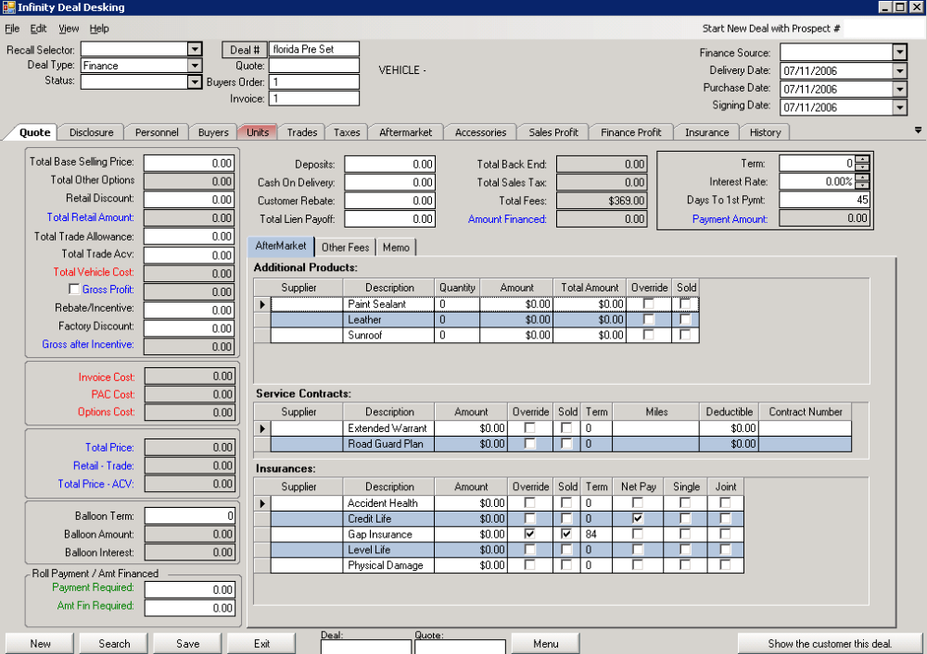

DEAL DESKING SCREEN

SYSTEMS 2000
INFINITY
DEAL DESKING
USER MANUAL

INPUTTING DEALS

The ability to input deals is the heart of Infinity Deal Desking. The menu and input screens are laid out to allow you to input deals quickly and efficiently.

Note: (The Exit button on each screen will take you out of the system completely; click the appropriate Tab to navigate from screen to screen.)

From this screen you can:

- Recall a deal, from the Recall Selector drop down list
- Start a New Deal, using the prospect number (Type the number in the prospect box located on the top right of the screen)
- Start a New Deal or Quote by clicking on the New button
- Search for a customer by clicking on the Search button

(DD. 1)
DEAL DESKING SCREEN
STARTING A DEAL

Start a Deal - click the New button on the Deal Desking Screen. (DD. 1)

This action takes you to the Choose Preset screen.

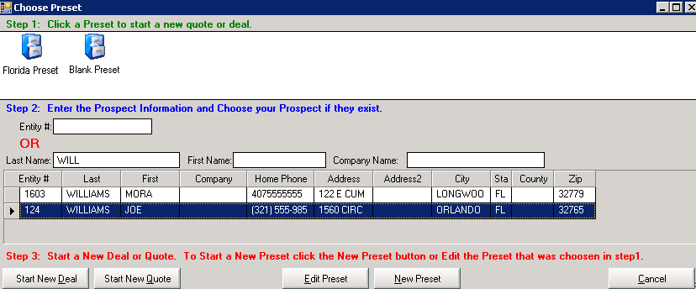
(DD. 14)
DEAL PRESET SCREEN

Step 1; Click on the desired Preset
Step 2, Fill in the Entity # or the Last Name, First Name, and/or Company Name – After typing the 4th character, the customer or the company name will appear if they have been already entered in any Infinity Modules. Highlight the correct Entity
Step 3; Click on the Start New Deal or the Start New Quote button

Note; if the Buyer was entered as a prospect in the Infinity CRM module, the Choose Buyer Info screen (See below) will appear - check, the information you would like to transfer directly into the Deal Desking module.

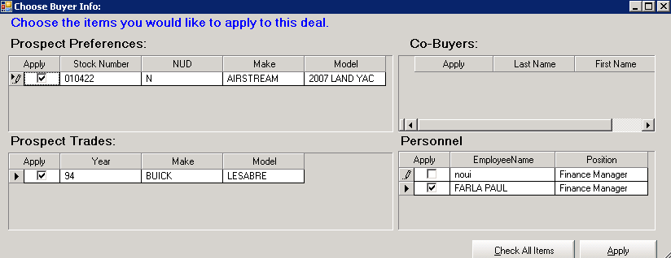

3
CHOOSE BUYER INFO SCREEN

Customer Search - click the Search button on the Deal Desking Screen. (DD. 1) if the customer did not appear on the Deal Preset screen (DD. 14)
The customer search feature allows you to save some time by not entering the customer information once again if he is already in the system.

This action will pop-up the Search Screen.

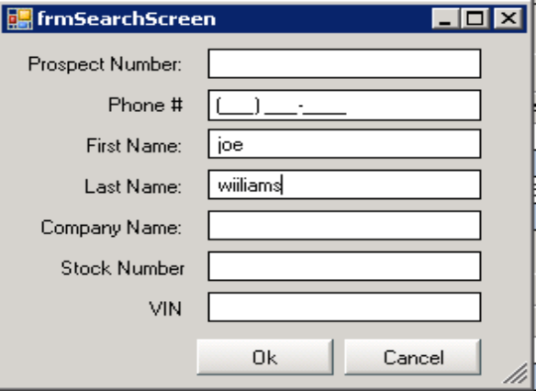

Fill in one or more fields: Last Name, First Name …etc, and then click OK.
This will activate a search that directs the system to explore all Infinity Systems to see if the customer is already in the system. When the filter results appear, select the customer from the list and the customer information will be updated into the deal.

If no results are found, click the Buyer tab on the Deal Desking screen.

Note: To change a Quote to a Deal, click on Deal #, a deal number will automatically appear. The quote will turn into a deal and you will have the ability to close out the transaction.

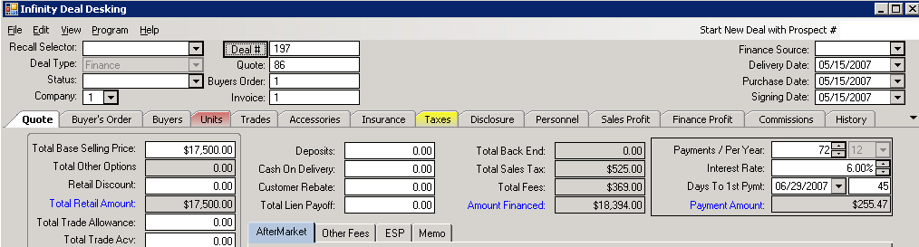

Enter a Buyer

This action will take you to the Buyer screen.

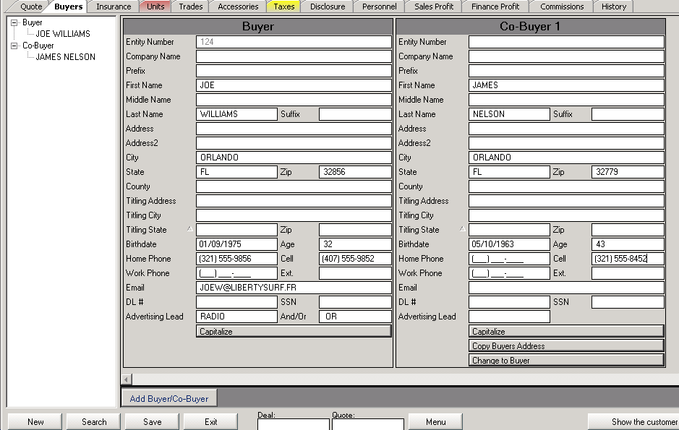
(DD. 15)
BUYERS SCREEN

Fill in the necessary information:

- Entity Number – Updates automatically
- Company Name (If applicable)
- Last Name
- First Name
- Address, City, State, Zip, County
- Birthday
- Phone Number
- Email
- Driver License Number
- Social Security Number
- And/Or – Enter the name in this field if another buyer is going to be on the Title.

Click the Capitalize button to capitalize your entries.

Click the Save button when finished.

To add a co-buyer, click the Add Buyer/Co-buyer button.

Each deal can have an unlimited number of buyers and co-buyers.

Choose a Vehicle - click the Units tab button on the Deal Desking Screen. (DD. 1)
The Unit tab displays the basic information associated with the stock number selected.

This action takes you to the Unit screen.

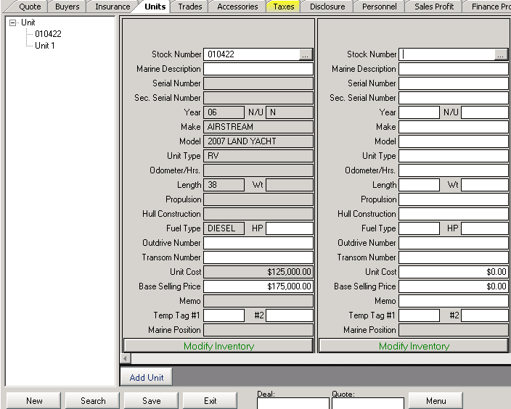
(DD. 16)
UNIT SCREEN

- Retail Stock Number – If the vehicle is on file, you can either enter the stock number manually or select it from the Stock Search screen, which can be viewed by clicking to the right of the field. The fields will populate automatically.

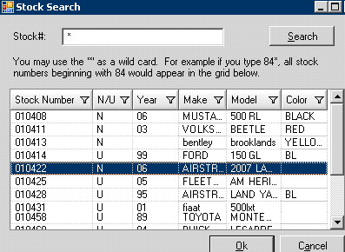

To add a unit, click the Add Unit button.
Multiple units can be sold on one deal.
Enter a Trade
Click the Trade tab on the Deal Desking Screen. (DD. 1)
The Trade tab allows you to input the information about the unit being traded.

This action takes you to the Trade screen.

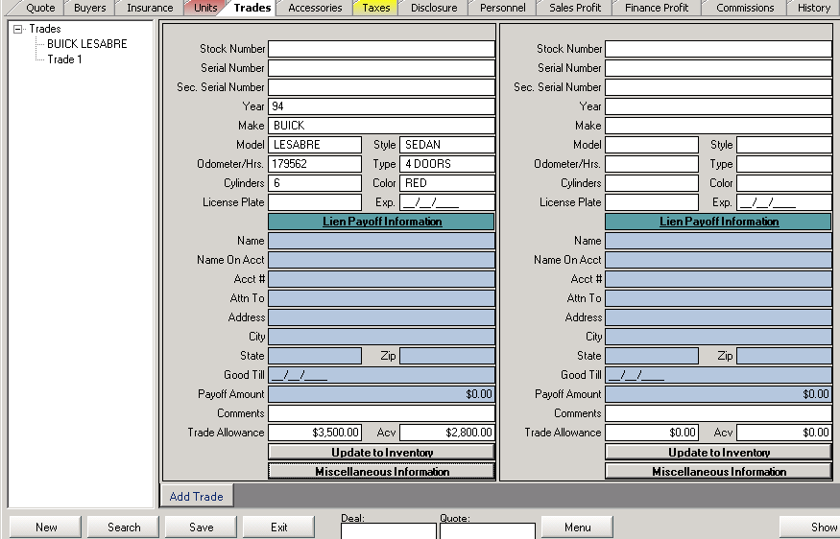
(DD. 17)
TRADE SCREEN

To add a trade, click the Add Trade button.

- Trade Stock Number – The stock number will update automatically if set up into company information to do so, or type it. Enter all the necessary information concerning the trade.
- Lien Payoff Information – If the trade is still under payment, select the lien payoff company from the drop down, the information will update automatically.
- Trade Allowance & ACV – Enter the amounts for the trade allowance and trade ACV (actual value).

Click the Miscellaneous Information button to enter a boat trade, and then click the Ok button.

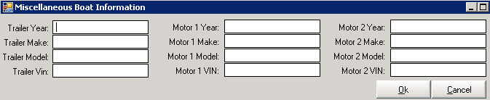

If you want this unit to show in your inventory, click the Update to Inventory button, and then click the Save button.

Each deal can have an unlimited number of trades.

Buyer, Unit and the Trade information will update in the Quote screen. (See next page)
The Quote Screen
The Quote screen is where your Sale is prepared; Get familiar with this screen.
The Quote screen allows the Sale Managers to work deals, figure gross profits, commissions, and transfer the deal directly to Accounting.

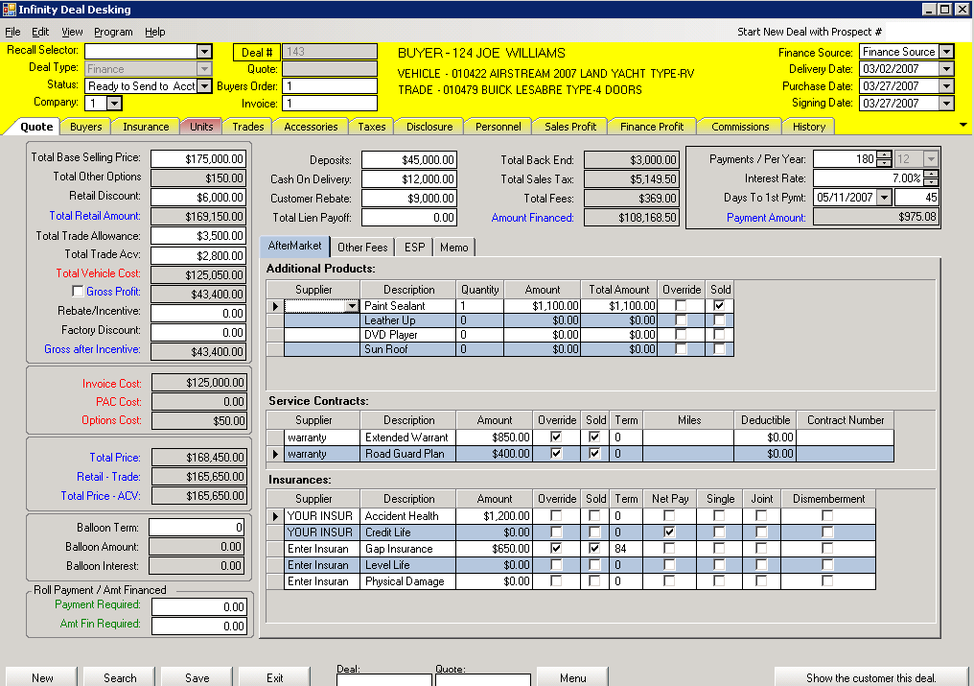 (DD. 18)
QUOTE SCREEN (Sale Manager View)

The Quote screen is for inputting the deal.

The screen is laid out in an easy-to-read format. You can switch between deals using the Recall Selector drop down list located at the top left of the screen.

Select:

- Deal Type – From the drop down list - Finance, Cash, Wholesale, Outside Lien, Lease, Dealer Trade, Quote, BHPH (Buy Here - Pay Here).
- Status – Select the description of the deal. The Status description can be modified (See the Add/Modify Status description section). The Status selection will change the color of the screen.
- Deal Number – This is the invoice or customer number that Accounting will use for posting the deal. This box will update automatically.
- Finance Source – Choose from the drop down list.
- Company – Select the company number from the drop down if you have multiple lots or locations.

Displayed information:

- Total Base Selling Price – If you do not want the pricing to come from the unit inventory when selecting a stock number, the system allows you to enter the base price, and retail discount separately. However, most dealerships enter the calculated price as the base selling price and skip the retail discount.
- Total Other Options – The amount comes from the added options found on the Accessories tab. The total is updated as the prospect accessorizes the unit
- Retail Discount – Enter any discount given to the customer.
- Trade Allowance – Enter the amount allowed for the customer’s trade - not the actual cash value.
- Trade ACV – Enter the actual value of the trade
- Total Vehicle Cost – The Total Cost is calculated from inventory. If a unit is package, it will be the total cost of all items in the package. The Cost is updated as the prospect accessorizes this unit.
- Gross Profit – The gross profit is calculated instantly for each prospect. The system allows you to enter a gross profit amount by checking the Gross Profit box: the Infinity system will work the figures backward to adjust the Retail Discount or the Total Trade Allowance.
- Rebate / Incentive, Factory Discount – Enter the discount given to your dealership by the manufacturer. Those discounts are Not being passed on to the customer.
- Invoice Cost – This is the cost of the unit.
- Pac Cost – This is the Pac cost of the unit in inventory. If it is a packaged unit, it will be the total Pac cost of each item in the package.
- Options Cost – The cost comes from the added accessories. The option cost is updated as the prospect accessorizes this unit.
- Total Price –This is the (Total Base Selling Price + Total Other Options + Total Trade ACV) – Total Trade Allowance.
- Balloon Term – If this loan has a balloon, meaning a large final payment in order to pay off the loan. Enter the number of months until the balloon becomes due.
- Balloon Amount – Enter the remaining amount at end of balloon term.
- Deposit – Enter the amount the customer is leaving as a put down to hold the deal. When a deposit is made, the system will automatically put On Hold the unit in the vehicle inventory for the next 2 days.
- Cash on Delivery – Enter the remaining amount the customer has to give upon delivery of the unit.
- Customer Rebate – Enter the discount given to the customer.
- Total Lien Payoff – Enter the amount that the customer still owes for the trade(s).This is a combined amount for all trades.
- Total Back End – The total After Market amount including Products, Contracts, and Insurance. This field will automatically update.
- Total Sales Tax, Total Fees, Amount Financed, and Payment Amount fields near the top right of the screen automatically update.
- Term – Enter the number of payments desired by the customer.
- Interest Rate – Enter the APR. (Annual Percentage Rate).
- Days to First Payment – Enter the number of days before the first payment is due.

The Buyer’s Order tab is where the salesperson prepares the deal; no costs are showing on this screen.

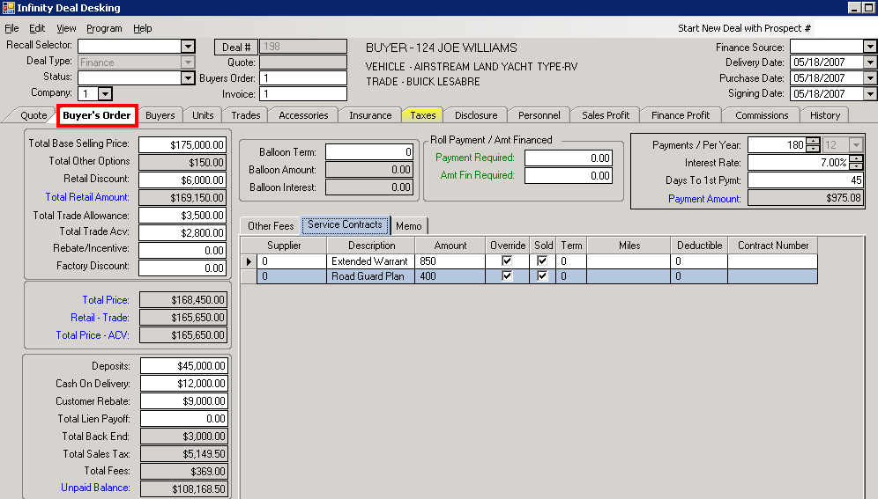

QUOTE SCREEN (Salesperson View)
Roll Payment / Amount Financed:

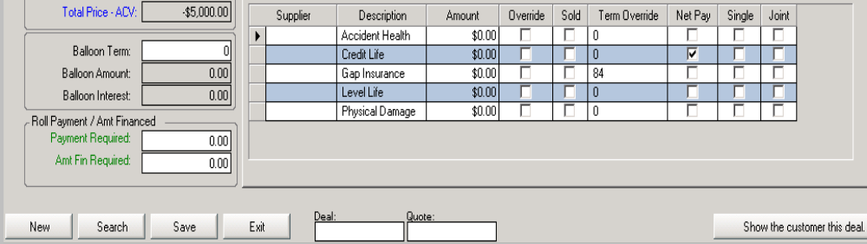
(DD. 18 A)

The Payment Required and the Amount Financed Required fields in the bottom left of the Quote screen (DD. 18 A) let you input the Payment or Finance amount desired by the customer.
Fill in the amount in the appropriate field, and then click Enter on your desktop.

The computer will show a different screen for each selection with choices of how much you have to adjust the Base Selling Price, the Trade Allowance, the APR, or the Cash Down to obtain the preferred payment.

Click on the appropriate box and Infinity will update the numbers.

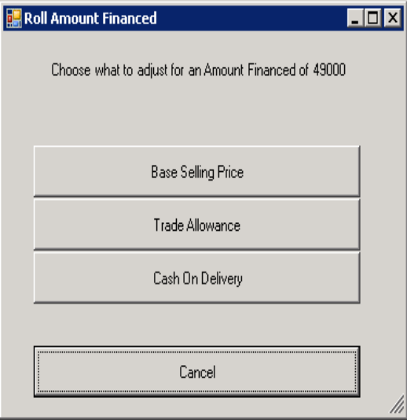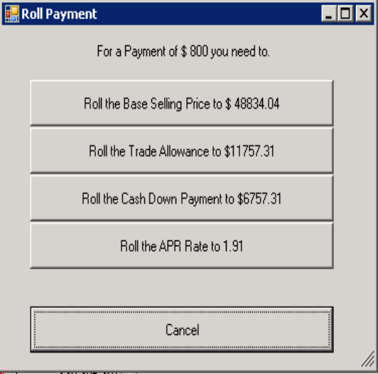

Use the AfterMarket, Other Fees, ESP and Memo tabs on the Quote screen (DD. 18) to enter the appropriate amounts, fees and memo corresponding with the deal.

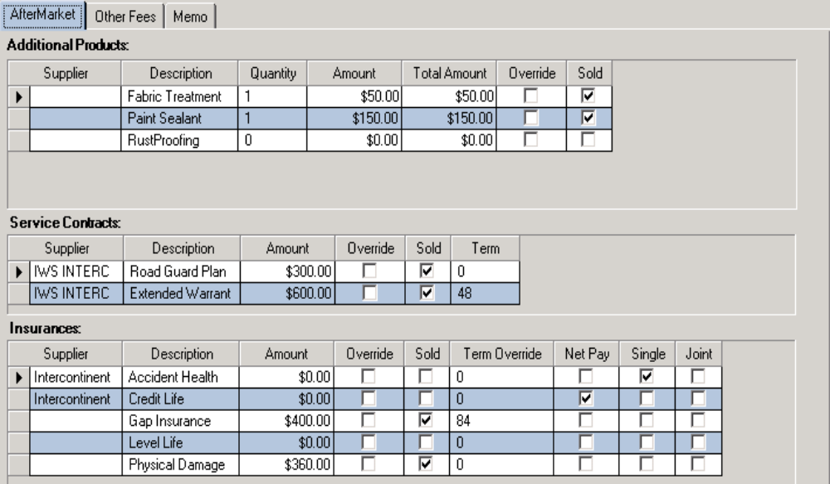
(DD. 19)
AFTERMARKET SCREEN ON THE QUOTE TAB

To sell an aftermarket product, check the Sold box.

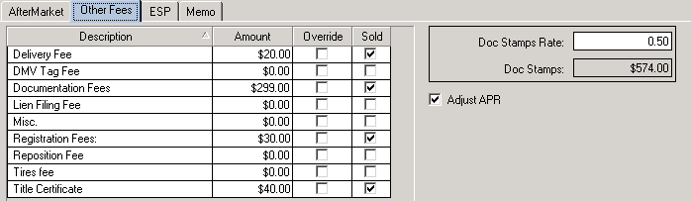
(DD. 20)
OTHER FEES SCREEN ON THE QUOTE TAB

Unlimited state and government fees can be included in each deal. These fees descriptions were set-up in the Add/Modify Fee section.

The Supplier and the Description, on the Aftermarket and Other Fees screen, fill in automatically from the Finance, Insurance, and Warranty Set-Up.
Enter the amount and the quantity for each corresponding box.

- Doc Stamp Rate – This is the rate for filling paper work and documentation, which is used in a per $100 calculation on the amount financed.
- Doc Stamp – This is a calculated field.
- Adjust APR for Bank Service Fee – Click so that a check mark appears if the bank service fees affect the interest rate.

Equity Savings Program

The Equity Savings Program requires sign up. The screen below shows you the Total Savings the customer will obtain through the program.

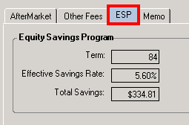

EQUITY SAVINGS PROGRAM SCREEN

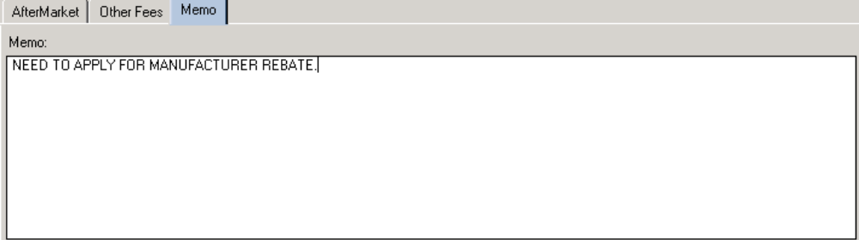

A memo pad stores notes specific to this deal.

MEMO SCREEN

The Memo screen allows you to write specific notes about the deal for future reference.

Remember to click the Save button at the bottom of the Deal desking screen after each update or change made.

Enter Employees on the Deal - click the Personnel tab on the Deal Desking Screen. (DD. 1)
The Personnel screen will appear.

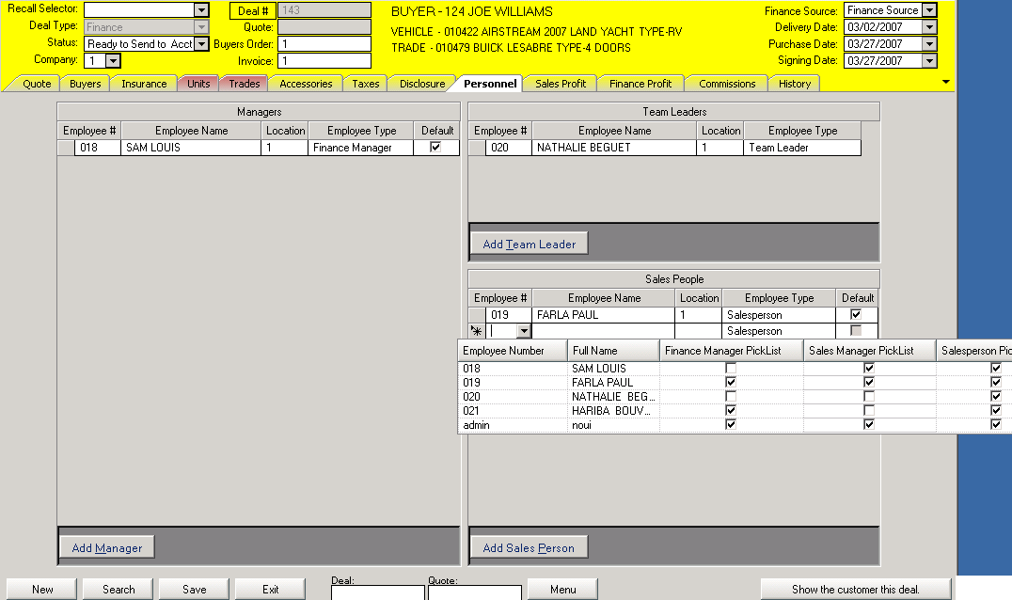
(DD. 21)
PERSONNEL SCREEN

You can add Manager, Team Leader, and Salesperson to the deal for commission purposes by clicking on the appropriate Add button.

Click on the Employee ID box and choose from the drop down list.

Click Save after each update.

Enter Commission on the Deal - Click the Commissions tab on the Deal Desking Screen. (DD. 1)

This action takes you to the Commissions screen.
The commissions screen let you view the commissionable amounts for the Sales Department, the Finance Department, as well as, the Retail Difference and the Total Gross for the unit.

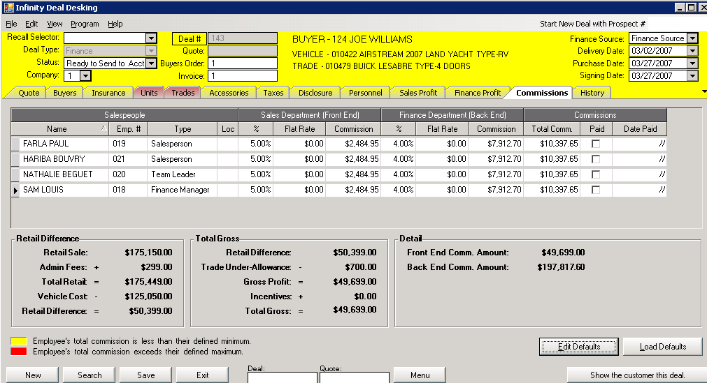
(SC. 1)
COMMISSIONS SCREEN

Click the Edit Defaults button, this action will open the Commission Defaults screen

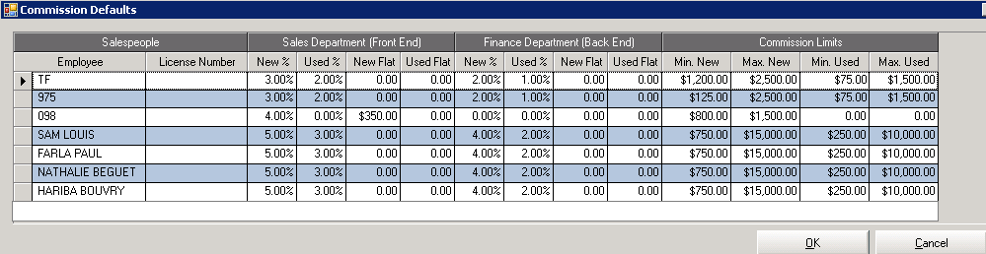

COMMISSION DEFAULTS SCREEN

Fill in the appropriate Percentages and Flat Amounts for each employee, as well as, the Commission Limits if applicable.
Click the Ok button when finished.

On the Commissions screen (CS. 1), click the Load Defaults button, the newly entered Percentages, Flat Amounts, and Commission Limits amounts will update the Commissions screen.

Enter Taxes - click the Taxes tab. on the Deal Desking Screen.
The Taxes tab allows you to select the state, county and city where this unit will be Titled and will charge the appropriate sales tax to the unit. If the title state tax of the unit differ from the buyer state of residency, the Taxes tab will turn yellow.

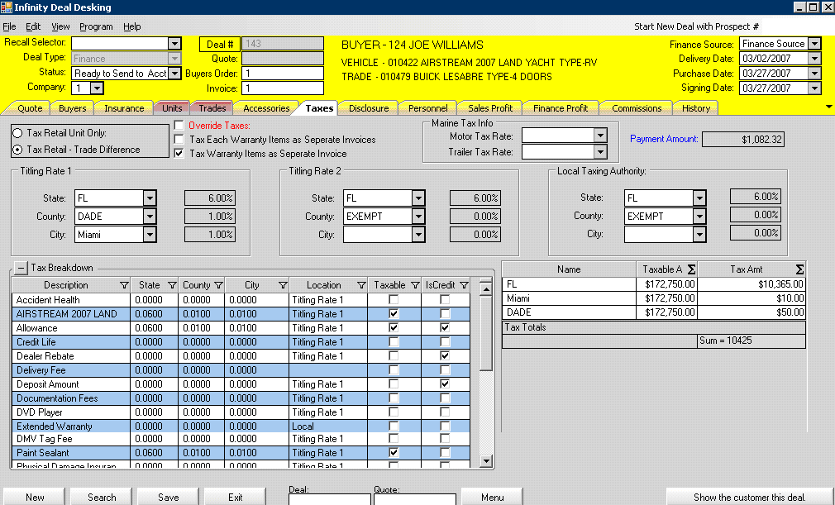 (DD. 22)
TAXES SCREEN

You can choose how and what to tax on this deal by checking:

- Tax Retail Unit Only
- Tax Retail and Trade Difference
- Tax Warranty Items as separate Invoices, or Tax Each Warranty Items as Separate Invoices
- Override Taxes – The system let you override the tax amounts with the appropriate permission

Note: there are three tax brackets for motorized (Titling Rate 1), non-motorized (Titling Rate 2), and local product sales (Local Taxing Authority) per deal.

Enter the following information:

- State Name – Enter the state name or select it from the drop down list.
- State Tax Rate – The rate populates automatically when the state is selected from the state name list.
To modify the State Tax Rate Table see the section on Sales Tax Rates.
- State Tax Amount – The amount will be calculated from state tax rate.
- County Name – Enter the county name or select it from the drop down list.
- County Tax Rate – The rate populates automatically when the county is selected from the county name list. To modify the county tax rate see the section on Sales Tax Rates.
- County Tax – The amount will be calculated from county tax rate.
- City Name – Enter the city name or select it from the drop down list.
- City Tax Rate – The rate populates when the city is selected from the city name list. To modify the city
tax rate see the section on Sales Tax Rates.
- City Tax Amount – The amount will be calculated based on city tax rate.

The Tax Breakdown table let you see every taxed and non-taxed item and fee, as well as, giving you an easy-to-read summary of the amount taxed and the total tax.

Look at the Financial Figures for the Deal - click the Disclosure tab.

This action takes you to the Disclosure screen.

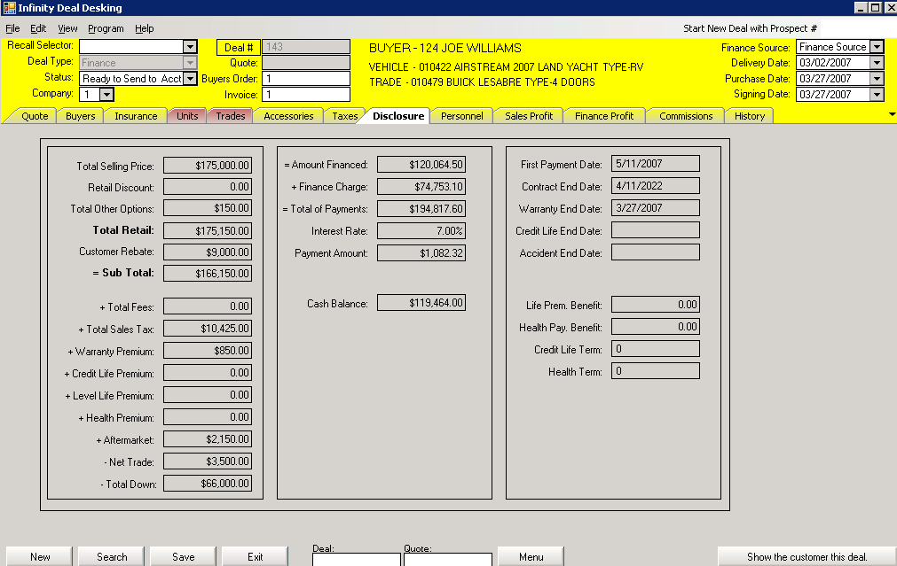
(DD. 24)
DISCLOSURE SCREEN

This screen shows the key financial figures for the customer’s deal. This screen is strictly for display and no input can be made. Use this screen to verify financial contracts, to make sure figures on the screen are matching what is on the contract.

To generate a paper version of this the Disclosure screen, click File then Print Disclosure on the Deal Desking Screen. (DD. 1)

Note: You will Not be Able to Change any Numbers on the Disclosure Screen.

Add Accessories or Parts to the Vehicle - click the Accessories tab.

This action takes you to the Accessories screen.

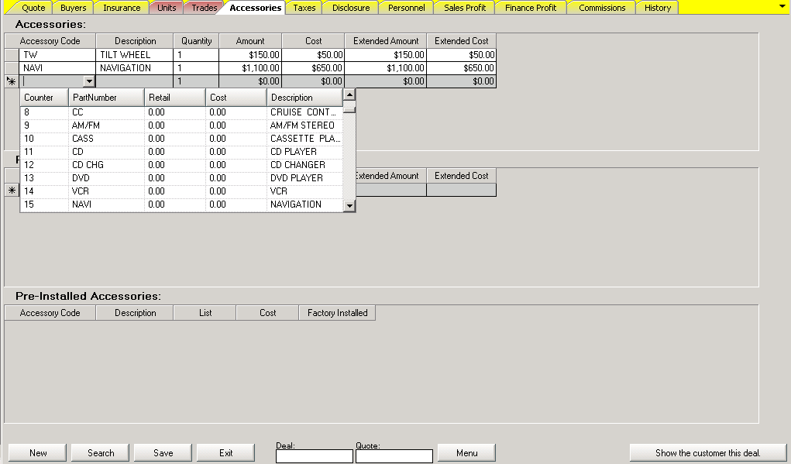
(DD. 25)
VEHICLE ACCESSORIES SCREEN

This screen allows you to build a unit and display option information on the Buyer’s Order. The accessory code drop down list can be populated by clicking on the right of the box. The description box will update automatically.
You can modify the Quantity, the Amount of the accessory as well as the Cost.

Note: The Accessory Code and the Description of the accessories are set-up in the Infinity Inventory Module.

Use the same step for adding Parts.

Pre-Installed Accessories: this part of the screen is only for viewing.

The cost and the price of the added accessories and parts will go over to the Total Other Option and Total Vehicle Cost on the Quote screen (DD. 18)

Click Save after each update.

Look at the Finance Profit for the Deal - click the Finance Profit tab.

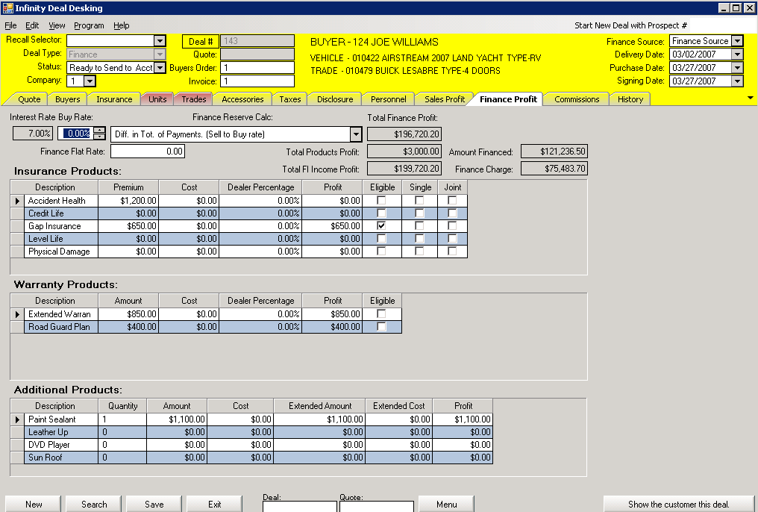
(DD. 26)
FINANCE PROFIT SCREEN

The Finance Profit screen gives the dealer a complete breakdown of the Profit and Cost related to Finance Profit, Insurance Products, Warranty Products, and Additional Products.

This screen allows you to enter the Cost of those products, as well as, the Finance Reserve Calculation, which you will select from the drop down list.

The Interest Rate comes from the Quote screen. The Total Finance Profit column displays how much your dealership will be making in Finance Reserve for this quote or deal. The calculation drop down will determine which formula is being used to calculate the finance reserve for this Finance source. The Default setting for this Finance source is set by clicking the Finance Source drop down on the Quote tab.

Click Save after each update.

Look at the Sale Profit for the Deal - click the Sale Profit tab.
The Sale Profit is also known as front-end profit.

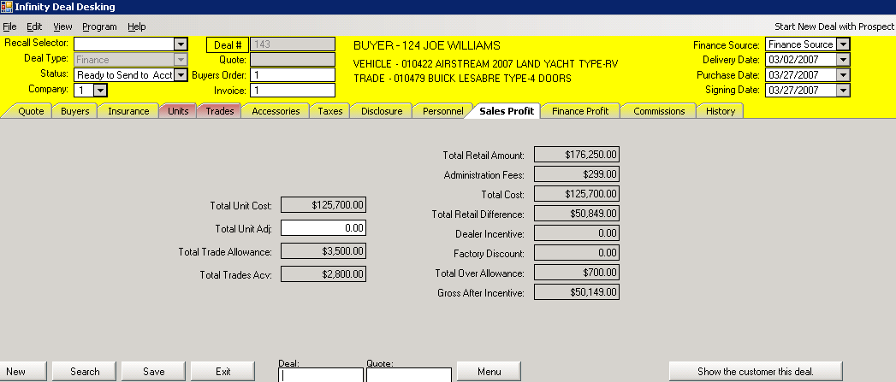
(DD. 27)
SALE PROFIT SCREEN

The Sale Profit screen gives the dealer an overview of the Costs, Administration Fees, Price, and Gross Profit associated with each unit.

- Total Retail Amount – The amount comes from the Total Retail field found on the Quote tab.
- Administration Fees – The Administration Fees can be used as profit, depending on how the system is setup. See your administrator to change the setting in company information setup, under finance.
- Total Cost – The total cost is the addition of the Unit Cost from the inventory and any adjustments entered in the Total Unit Adj. field.
- Total Retail Difference – The amount is the result of subtracting the Total Retail price minus the Total Unit Cost and depending on how you are using the administration fees; it may add the administration fees.
- Dealer Incentive and Factory Discount – These figures are transferred from the Quote tab.
- Total Over Allowance – Over allowance is the difference between the Total Trade Allowance and the Total Trade ACV.
- Gross After Incentive – The Gross is calculated by adding the dealer incentive and factory discount to the retail difference and then subtracting the over allowance.

Enter Customer Insurance Information - click the Insurance tab.

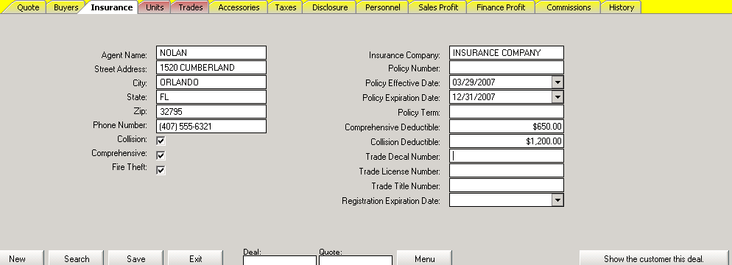
(DD. 28)
INSURANCE INFO SCREEN

Enter the following information:

- Agent’s Name – Enter the name of the agent, not the insurance company.
- Agent’s Street Address, City, State, Zip Code
- Telephone Number – Enter the agent’s phone number.
- Comprehensive – Check the box if applicable.
- Collision – Check the box if applicable.
- Fire & Theft – Check the box if applicable.
- Insurance Company Name, Policy Number
- Policy Effective Date, Policy Expiration Date – Enter the dates that the coverage starts and end.
- Policy Term
- Comprehensive Deductible, Collision Deductible
- Trade Decal Number – Number found on the Trade Decal for licensing purposes.
- Trade License Number – Trade License Number that is currently titled in.
- Trade Title Number
- Registration Expiration Date

Note: The Trade Decal Number, License Number, Title Number, and Registration Expiration Dates may not match the exact terminology used by the State the business is located. They are simply used to gather data to be able to print on titling forms.

To specify which kind of insurance is included, check the appropriate boxes:

- Comprehensive – Check the box if applicable.
- Collision – Check the box if applicable.
- Fire & Theft – Check the box if applicable.

Click Save after each update.

Look at the History of the Deal - click the History tab.

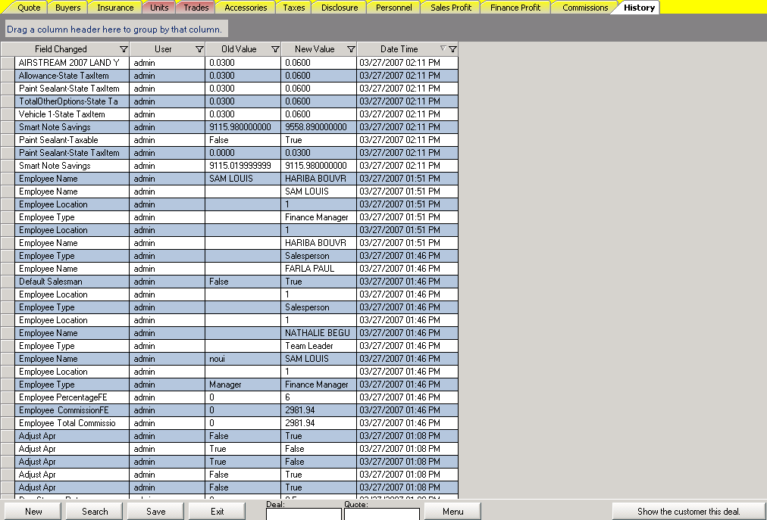
(DD. 29)

HISTORY SCREEN

The system tracks every change made on every deal. You can quickly identify Who changed the deal, What changes were made, and When the deal was changed.

This screen allows the dealer to see any fields that have been changed on the deal, the User (the person that made the changes), the Old Values before the changes, the New Values, and the Date and Time that those modifications occurred.

The Menu button: click this button to display the Infinity Menu Selling system. The Menu system allows your dealership employees to set-up and sells Aftermarket products as Packages within different Plans. (See the Menu Selling Manual).

Show the Customer the Deal - click Show the customer this deal.

The button is on every screen at the bottom right corner (See DD. 29).



This action will take you to the Customer Sales View screen (See picture below).

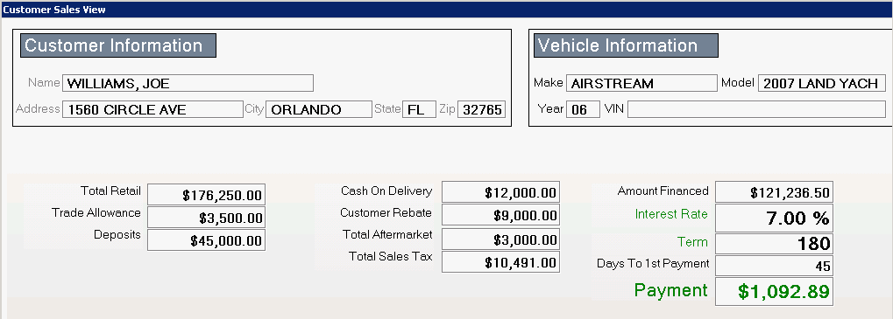
(DD. 30)
CUSTOMER SALES VIEW SCREEN

This screen show:

- Customer Information
- Vehicle Information
- Base Selling Price of the Unit
- Other Options
- Total Aftermarket
- Total Sales Tax
- Total Fees
- Amount Financed
- Interest Rate
- Term
- Number of Days to 1st payment
- Payment Amount

Note: No Profit Amounts or Commission Amounts are shown on this screen at anytime.

The Screen will Fade Away After 30 seconds.

PRINTING CONTRACTS AND FORMS

Infinity can print Bank Contracts and other Forms for you.
As part of our Support Agreement, Systems 2000, Inc. will gladly program all necessary forms. Please send three copies of each form that you want programmed to the support department at Systems 2000, Inc.

Print Contracts and Forms

Click File then Print Docs on the Deal Desking Screen. (DD. 1)

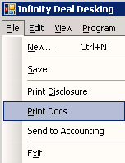

This action takes you to the Finance Documents Selection.

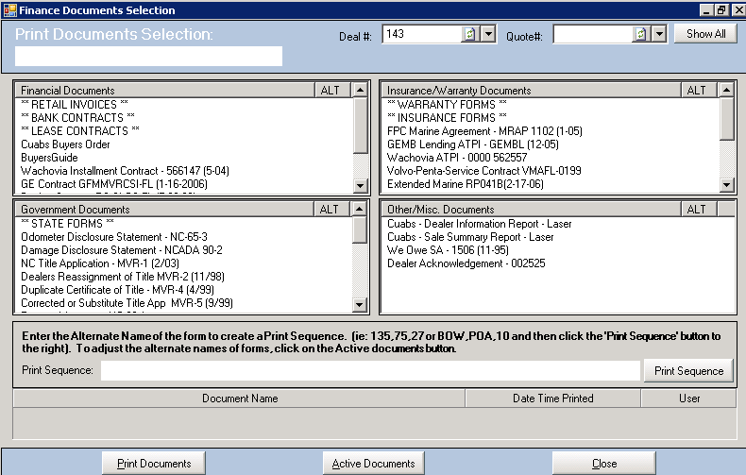
(DD. 33)
FINANCE DOCUMENTS SELECTION SCREEN

The Deal or Quote number will populate instantly.

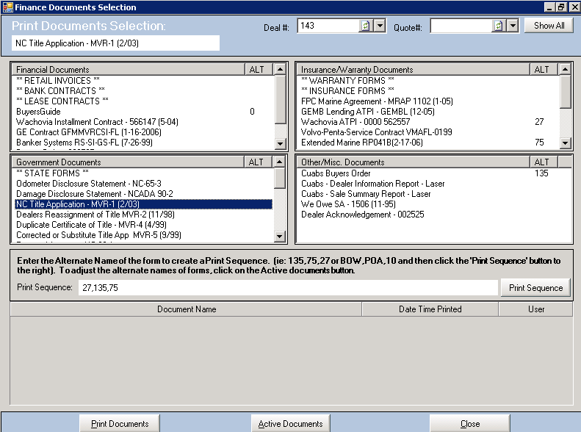

The screen lists all Bank Contracts and other Forms programmed for your system. They are grouped into four menus.

- Financial Documents ( 1 )
- Insurance / Warranty Documents ( 2 )
- Governmental Documents ( 3)
- Other Miscellaneous Documents ( 4 )

Instruction for printing forms:

- Enter the Deal Number or Quote Number or select the appropriate number from the drop down list.
- Highlight the Contract or Form to be printed, by clicking on it. The name will appear in the box at the top of the screen.
- Click the Print Document button.

The system allows you to print multiple forms at the same time. Enter the Alternate Name (See DD 34) of the form to create a Print Sequence ex. (135, 75, 27, or BOW, POA10) and then click the Print Sequence button.

A visual of the selected forms will pop up. (See next page)

Example of a selected form:

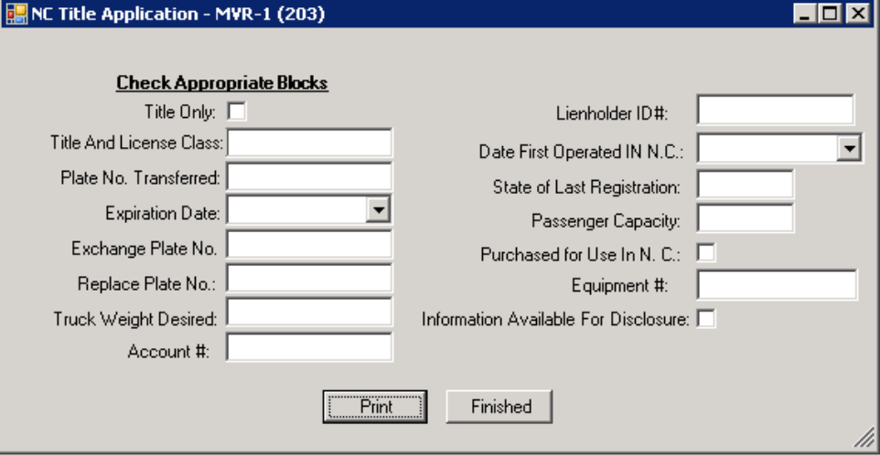

NC Title Application Screen

Click Print, and then Finished.

Note: Click Active Documents on the Finance Documents Selection screen (DD. 33), the Active Documents screen will appear. You can view or amend a list of documents that you would like to access through the Print Documents Selection screen, by clicking the box in the Active column.

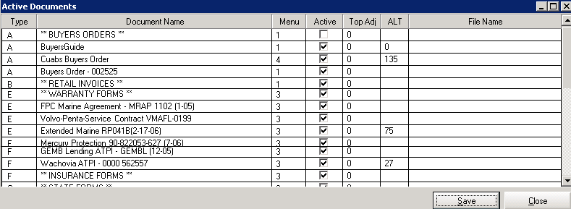
(DD. 34)
ACTIVE DOCUMENTS SCREEN

- The letters on the column Type are related to the different forms ex; (A – Buyers Order, F – Insurance forms…)
- The numbers on the Menu column represent the four different groups ex; (1 Financial Documents, 3 Governmental Documents…)
- The Top Adj. column allows you to enter numbers in inches to align the printing on the forms ex; (- 0.02 or 0.02) will move the printing 0.02 lower or 0.02 higher on the form.
- The ALT column permits you to enter Alternate Names for the forms for easier use of the Printing Sequence. Ex; (Instead of typing Wachovia ATPI – 0000 562557, Cuabs Buyers Order for the printing sequence just type 27,135)

Click Save when finished

Close Out a Deal

Click on the Status drop down list, select an External Status with a Done as an Internal status.

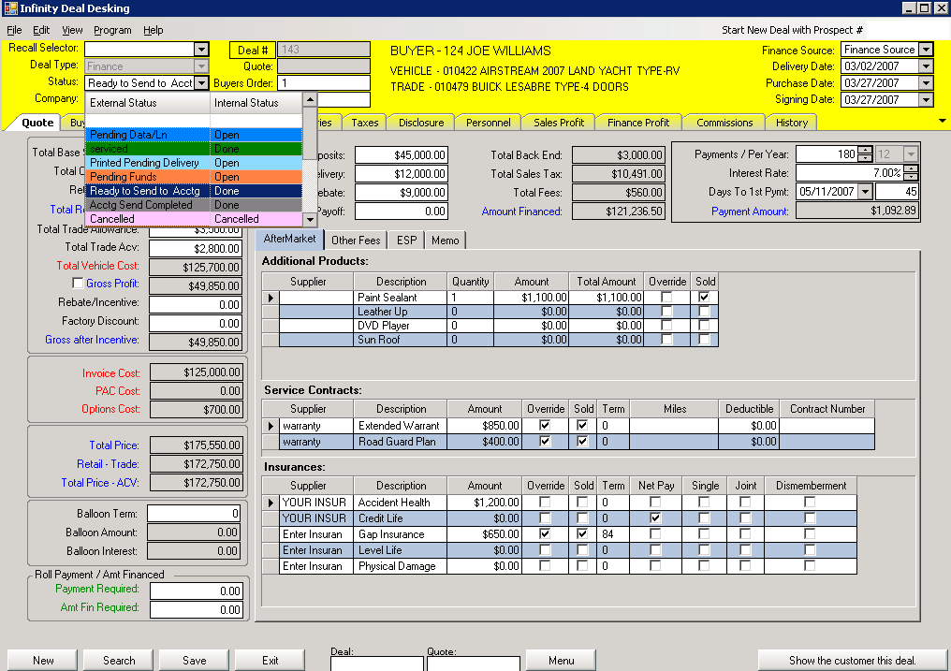

Click the Save button, the top part of the screen will change color according to the status selected.

Click File then Send to Accounting on the Infinity Deal Desking Screen. (DD. 1)

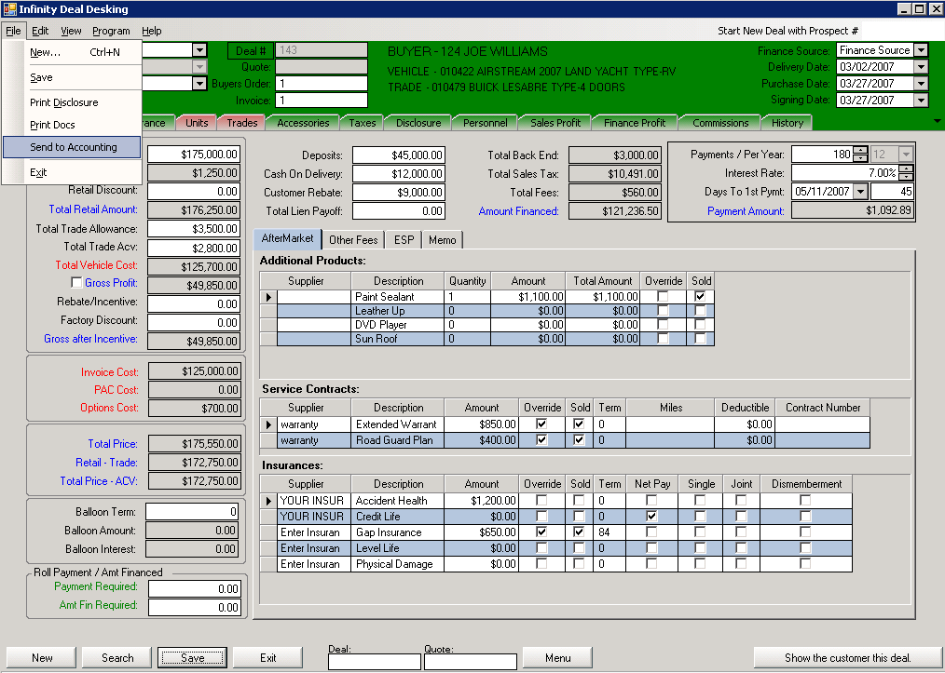

This action will pop up the screen see below.

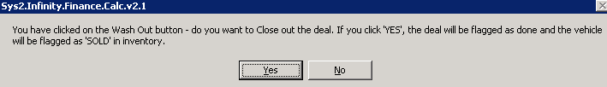

If you are done with the deal and you have sold the unit click YES, the vehicle or the unit will be flagged as SOLD in inventory and the Unit Status screen will pop up. (See picture on the next page).

If you are not done with the deal and you have not sold the unit yet click NO, you will be sent back to the Deal Desking screen.

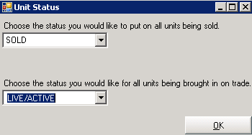

The Unit Status screen allows you to choose from the drop down list, the Status you would like to put on all units being sold, as well as the status you would like for all units being brought in on trade and then click OK.

The Purchase Price Update screen comes up.

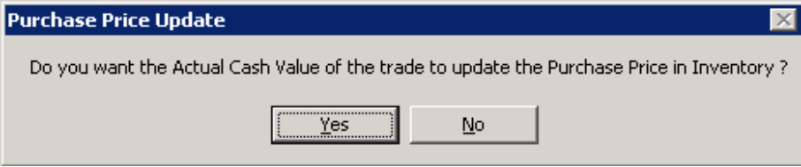

Answer YES if you want the actual cash value of the trade as the purchase price in inventory.

If you are using our Accounting Module, the NEXT STEPS ARE CRITICAL TO FOLLOW for the deal to show in accounting. If you are not using our accounting system, disregard.

At this time, on the Deal Desking screen, click File, Send to Accounting, and the Accounts Summary Templates screen pop up. (See Below).

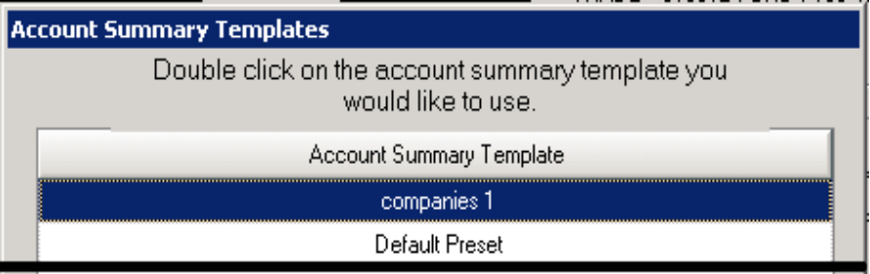

Double click on the Account Summary Template you would like to use.

This action takes you to the Accounting Summary screen. (See next page)

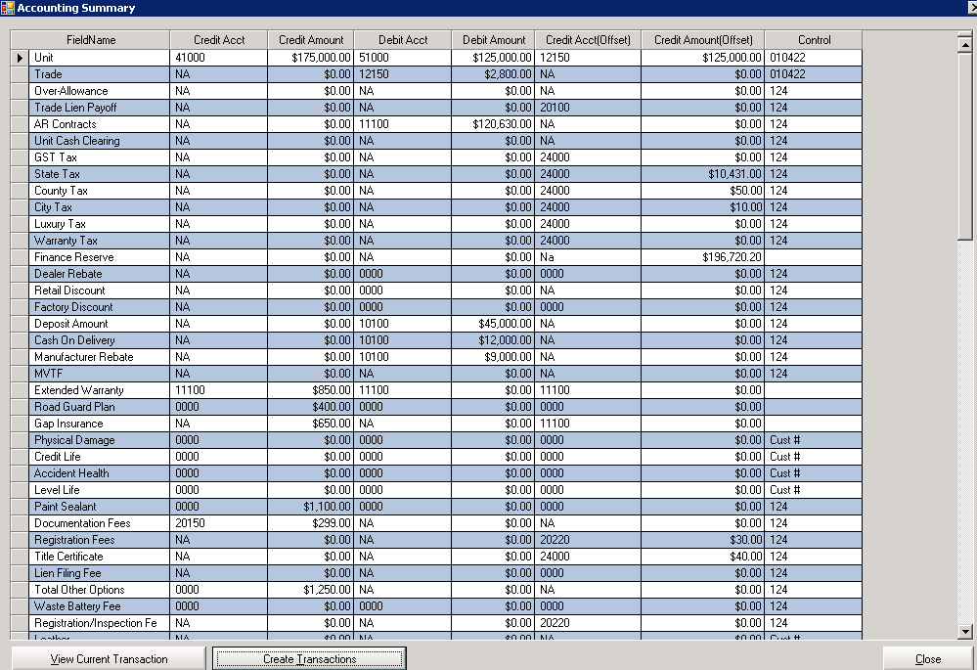
(DD. 31)

ACCOUNTING SUMMARY SCREEN

The Accounting Summary screen gives the employee a detailed view of all the credit and debit accounts and amounts.

Click the View Current Transaction key at the bottom right of the Accounting Summary screen to look at a more concerted view of all amounts related to the Deal.

Click Create Transactions key if everything looks correct.

This action takes you to the Accounting Transaction screen. (See next page)

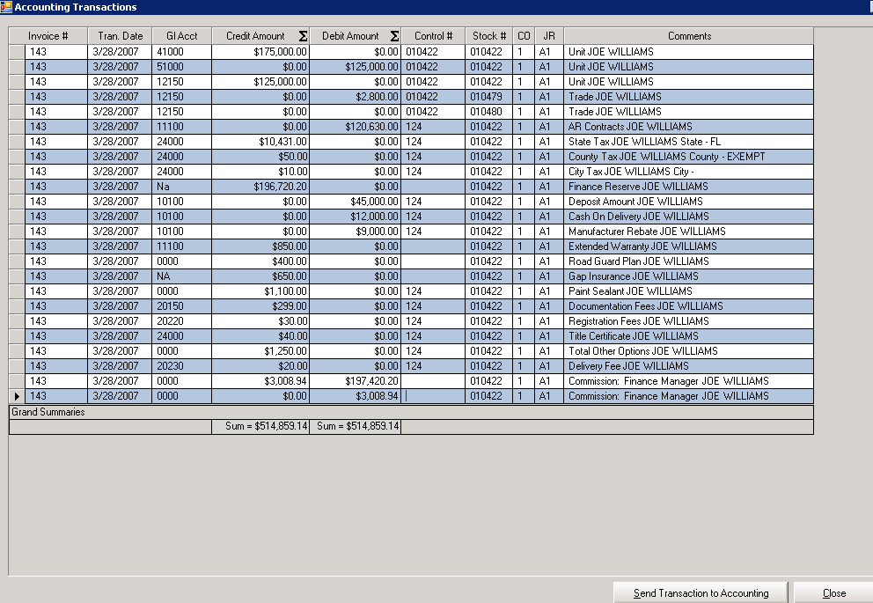
(DD. 32)

ACCOUNTING TRANSACTIONS SCREEN

This screen is the final step before sending the deal to accounting.
Make sure that the Credit Sum Amount and the Debit Sum Amount in the Grand Summaries boxes balance. If so, click the Send Transaction to Accounting button.



